Azure Monitoring Hackathon Proctor Guide

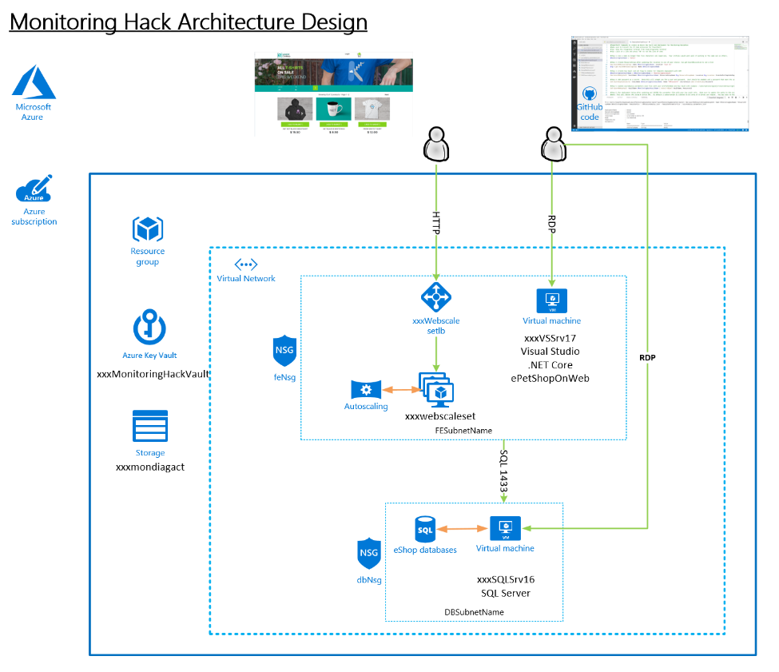

Version 1.0

Author: Rob Kuehfus

Please send feedback to here - <https://github.com/rkuehfus/AzureMonitoringHackathon>

Contents

Hack Setup 3

Guidance 3

Day 1: Monitoring and Alert Rule Challenge 4

Day 1: Monitoring and Alert Rule Automation Challenge 26

Day 2: Log Analytics Setup Challenge 30

Day 2: Log Analytics Dashboard Challenge 46

Day 3: Application Insights Challenges 55

# Hack Setup

* Deploy Infra using PowerShell \ CLI and an ARM Template
  + Setup Azure Module on Windows PowerShell  
    <https://docs.microsoft.com/en-us/powershell/azure/install-azurerm-ps?view=azurermps-6.9.0>
  + Setup Azure CLI  
    <https://docs.microsoft.com/en-us/cli/azure/install-azure-cli?view=azure-cli-latest>
  + Install Visual Studio Code and Extensions (depending on your tool of choice)
    - Azure Resource Manager Tools - <https://marketplace.visualstudio.com/items?itemName=msazurermtools.azurerm-vscode-tools>
    - ARM snippets - <https://marketplace.visualstudio.com/items?itemName=artofshell.armsnippet>
    - PowerShell - <https://marketplace.visualstudio.com/items?itemName=ms-vscode.PowerShell>
    - Azure CLI Tools –   
      <https://marketplace.visualstudio.com/items?itemName=ms-vscode.azurecli>
  + Download Azure Monitoring Hackathon Setup Guide and follow the instructions  
    <https://github.com/rkuehfus/AzureMonitoringHackathon/raw/master/Student/Guides/Azure%20Monitoring%20Hackathon%20Deployment%20Guide.docx>

Navigate to <https://github.com/rkuehfus/AzureMonitoringHackathon> and download the repository as a zip file to your local disk

## Guidance

Biggest issues I have seen when deploying the hack are around compute quotas, not having contributor role membership to the subscription and local machine issues. If you run into a student who cannot seem to get their computer working with either the Azure CLI or PowerShell have them build a VM in Azure and configure this VM to do the deployment. Another option would be to have them run the deployment from the Azure Cloud Shell. Remember to copy up the ARM template and parameters JSON files before kicking off the deployment.

I highly recommend your students make sure they have an Azure Subscription they have contributor role access to before day one of the hack.

# Day 1: Monitoring and Alert Rule Challenge

* Create an empty database called “tpcc” on the SQL Server  
  Note: Use SQL Auth with the username being sqladmin and password being whatever you used during deployment
  + Connect (RDP) to the Visual Studio Server (xxxxxVSSrv17) using its public IP address and open Visual Studio. Create an account if you don’t have one.
  + VS has view called SQL Server Object Explore that can be used to create and delete SQL databases on the SQL server  
    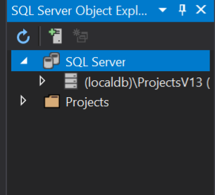
  + Connect to the database server, make sure to use sqladmin and the password you stored in the key vault during deployment  
    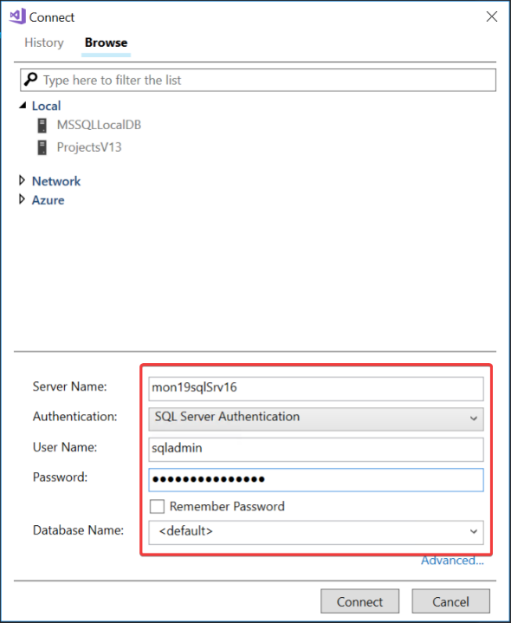  
    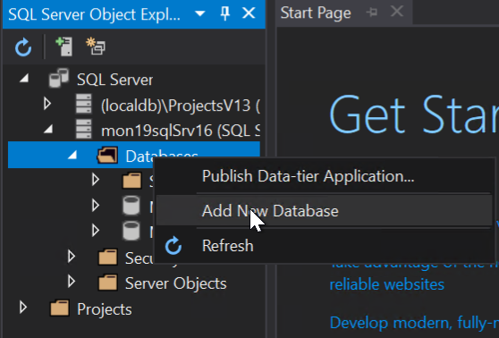  
    Once connected create a new database called “tpcc”

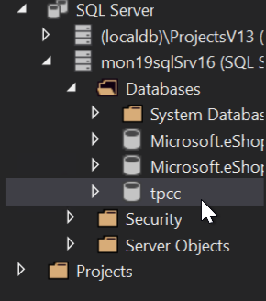

* From the ARM template, send the below guest OS metric to Azure Monitor for the SQL Server
  + Add a Performance Counter Metric for
    - Object: SQLServer:Databases
    - Counter: Active Transactions
    - Instance:tpcc
  + Hint: <https://docs.microsoft.com/en-us/azure/monitoring-and-diagnostics/metrics-store-custom-guestos-resource-manager-vm>
  + First, figure out the correct format for the counter use the run command on the SQL Server in the Azure portal and run –

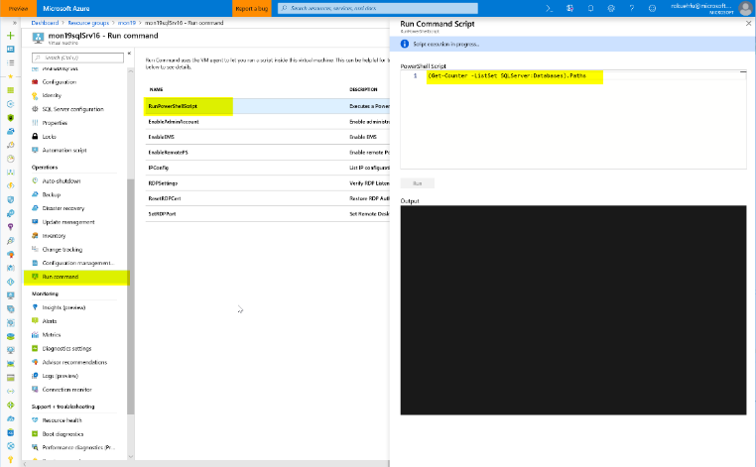

Run the command - (Get-Counter -ListSet SQLServer:Databases).Paths

Once its finished, review the results (scroll up) and copy the output for the SQLServer:Databases counter.  
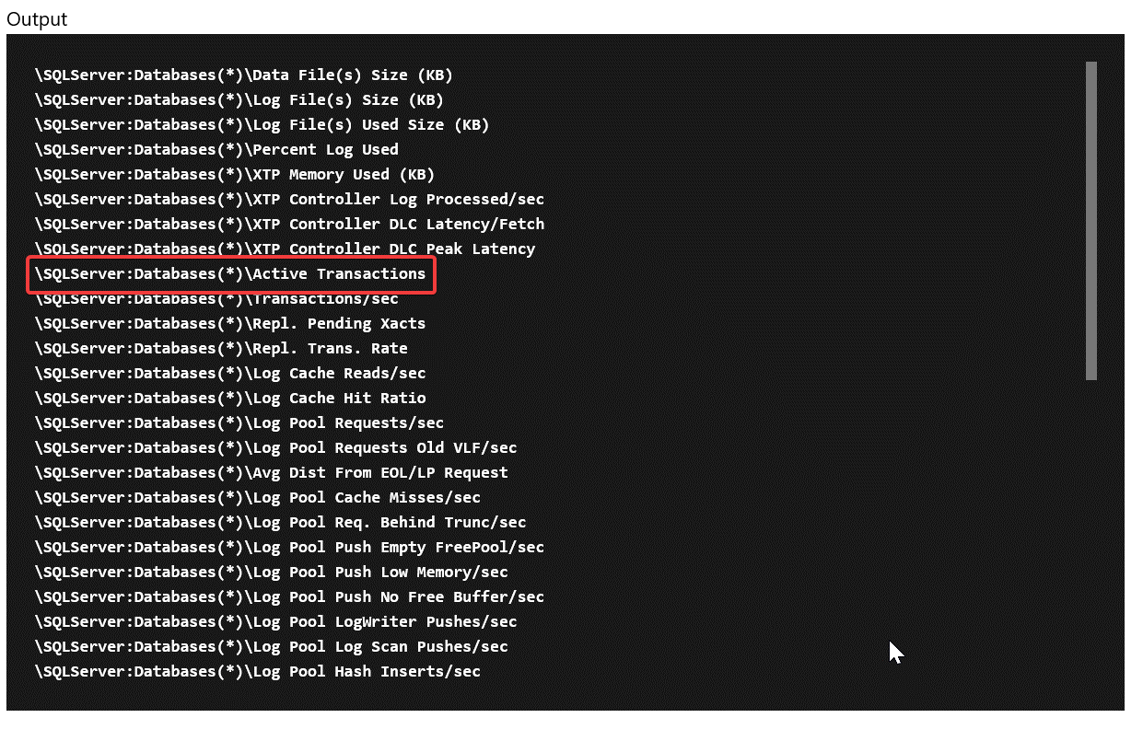

\SQLServer:Databases(*)\Active Transactions

Then change it to target just your specific database

\SQLServer:Databases(tpcc)\Active Transactions

**Tip:** Share the following link to help lead them to how to find the counter

<https://docs.microsoft.com/en-us/powershell/module/microsoft.powershell.diagnostics/get-counter?view=powershell-5.1>

Next, once you have the counter you need to modify the ARM template for the SQL Server to add the collection of this counter that sends it to Azure Monitor using the Azure monitor data sink

Add this JSON to the SQL Server code

Verify the identity is present in the template (add it if its missing)

"identity": {

"type": "SystemAssigned"

},

And the missing counter below

"resources":[

{

"type": "extensions",

"name": "Microsoft.Insights.VMDiagnosticsSettings",

"apiVersion": "2015-05-01-preview",

"location": "[resourceGroup().location]",

"dependsOn": [

"[concat('Microsoft.Compute/virtualMachines/', concat(parameters('envPrefixName'), 'sqlSrv16'))]"

],

"properties": {

"publisher": "Microsoft.Azure.Diagnostics",

"type": "IaaSDiagnostics",

"typeHandlerVersion": "1.5",

"autoUpgradeMinorVersion": true,

"settings": {

"WadCfg": {

"DiagnosticMonitorConfiguration": {

"overallQuotaInMB": 4096,

"DiagnosticInfrastructureLogs": {

"scheduledTransferLogLevelFilter": "Error"

},

"Directories": {

"scheduledTransferPeriod": "PT1M",

"IISLogs": {

"containerName": "wad-iis-logfiles"

},

"FailedRequestLogs": {

"containerName": "wad-failedrequestlogs"

}

},

"PerformanceCounters": {

"scheduledTransferPeriod": "PT1M",

"sinks": "AzMonSink",

"PerformanceCounterConfiguration": [

{

"counterSpecifier": "\\Memory\\Available Bytes",

"sampleRate": "PT15S"

},

{

"counterSpecifier": "\\Memory\\% Committed Bytes In Use",

"sampleRate": "PT15S"

},

{

"counterSpecifier": "\\Memory\\Committed Bytes",

"sampleRate": "PT15S"

},

{

"counterSpecifier": "\\SQLServer:Databases(tpcc)\\Active Transactions",

"sampleRate": "PT15S"

}

]

},

"WindowsEventLog": {

"scheduledTransferPeriod": "PT1M",

"DataSource": [

{

"name": "Application!*"

}

]

},

"Logs": {

"scheduledTransferPeriod": "PT1M",

"scheduledTransferLogLevelFilter": "Error"

}

},

"SinksConfig": {

"Sink": [

{

"name": "AzMonSink",

"AzureMonitor": {}

}

]

}

},

"StorageAccount": "[variables('storageAccountName')]"

},

"protectedSettings": {

"storageAccountName": "[variables('storageAccountName')]",

"storageAccountKey": "[listKeys(variables('accountid'),'2015-06-15').key1]",

"storageAccountEndPoint": "https://core.windows.net/"

}

}

},

{

"type": "extensions",

"name": "WADExtensionSetup",

"apiVersion": "2015-05-01-preview",

"location": "[resourceGroup().location]",

"dependsOn": [

"[concat('Microsoft.Compute/virtualMachines/', concat(parameters('envPrefixName'), 'sqlSrv16'))]"

],

"properties": {

"publisher": "Microsoft.ManagedIdentity",

"type": "ManagedIdentityExtensionForWindows",

"typeHandlerVersion": "1.0",

"autoUpgradeMinorVersion": true,

"settings": {

"port": 50342

}

}

}

]

Save and redeploy.

Once redeployed, go to metrics and check to make sure you are seeing the new metrics.   
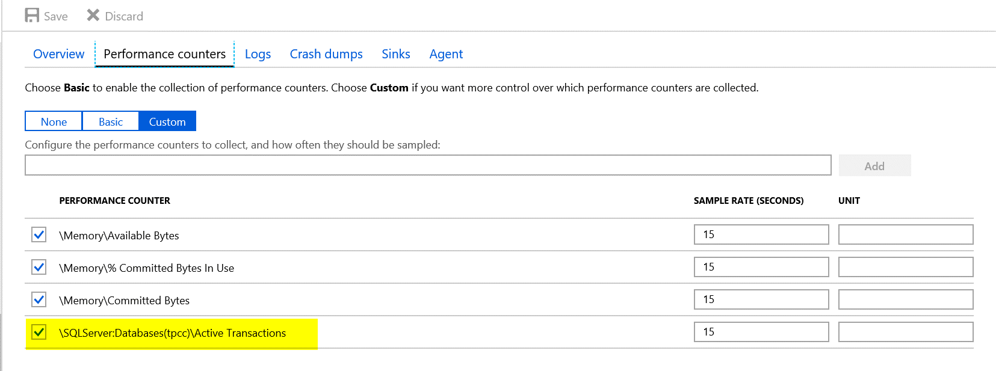

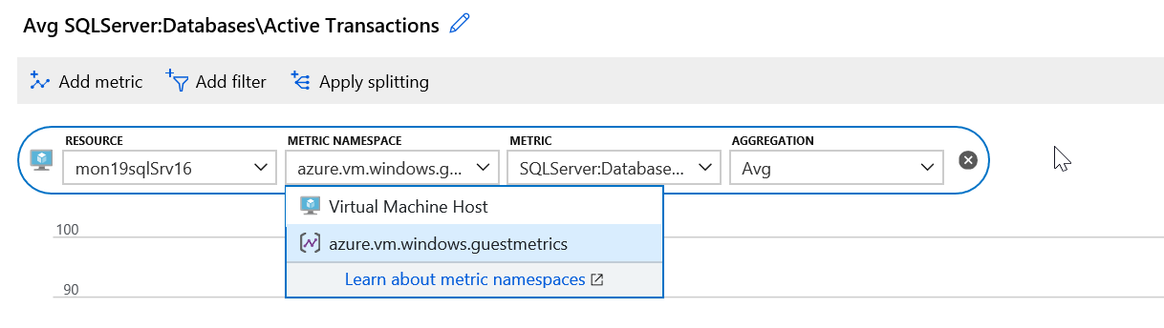

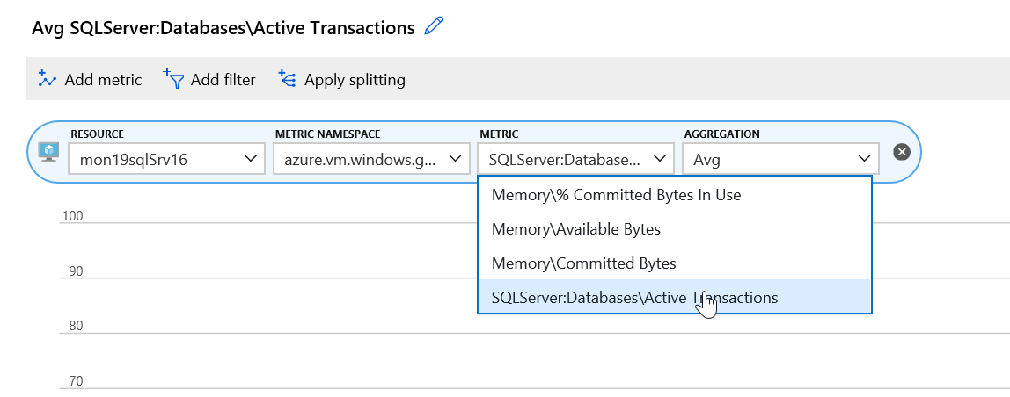

**Tip:** A bunch of OS metrics are configured already under the scale set as a sample.

* Download and Install HammerDB tool on the Visual Studio VM. Note: I copy of these instructions are in the student folder under “AzureMonitoringHackathon\Student\Guides\Day-1”
  + [www.hammerdb.com](http://www.hammerdb.com/)

From the Visual Studio Server, download the latest version of HammerDB  
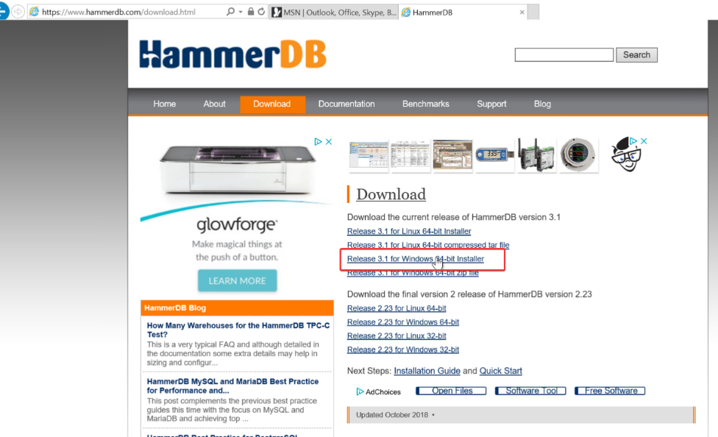

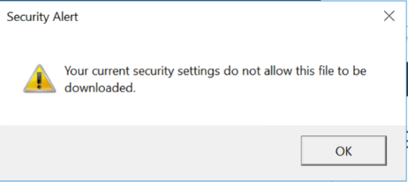

If you get this Security Warning, go to Internet Options.

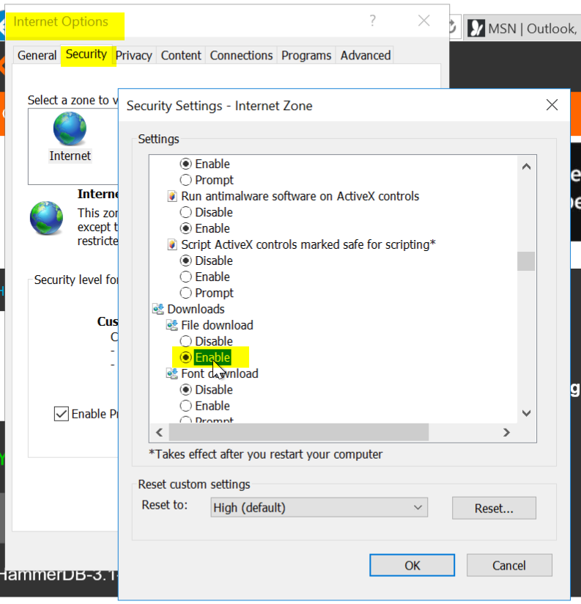

Security \ Security Settings \ Downloads \ File download \ Enable

Click OK

Try again



Click Actions and accept the warnings

Tip: If you end up closing HammerDB you have to go to C:\Program Files\HammerDB-3.1 and run the batch file

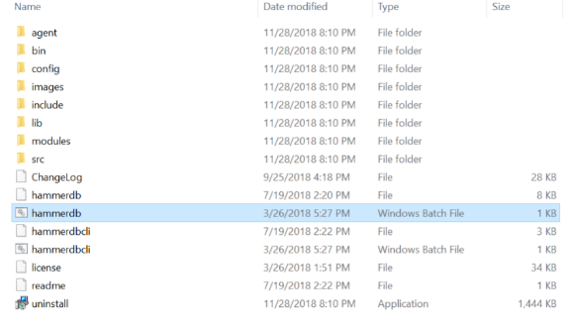

* Use HammerDB to create transaction load

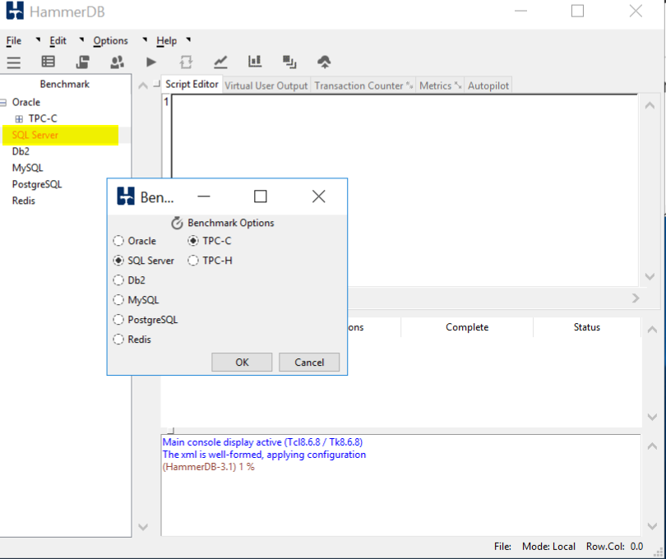

Double click on SQL Server and click OK, and OK on the confirm popup

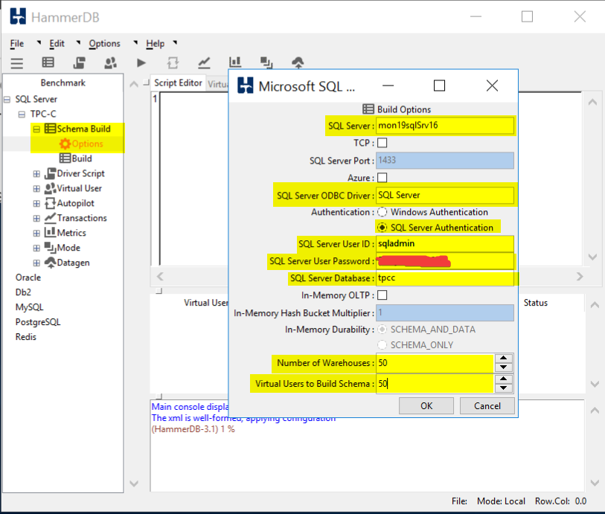

Drill into SQL Server \ TPC-C \ Schema Build and double click on Options

Modify the Build Options for the following:

SQL Server: Name of your SQL Server

SQL Server ODBC Driver: SQL Server

Authentication: SQL Server Authentication

SQL Server User ID: sqladmin

SQL Server User Password: <password you stored in the Key Vault>

SQL Server Database: tpcc

Number of Warehouses: 50

Virtual Users to Build Schema: 50

Note: Setting the last two at 50 should generate enough load to trip a threshold and run long enough for you to graph

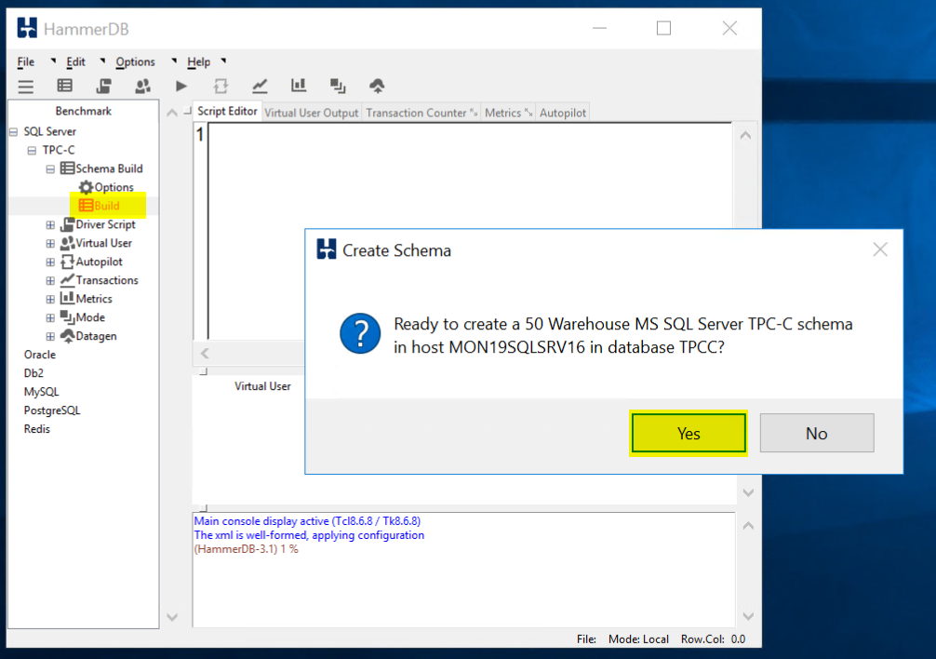

Double click on Build and Click Yes to kick of a load test.

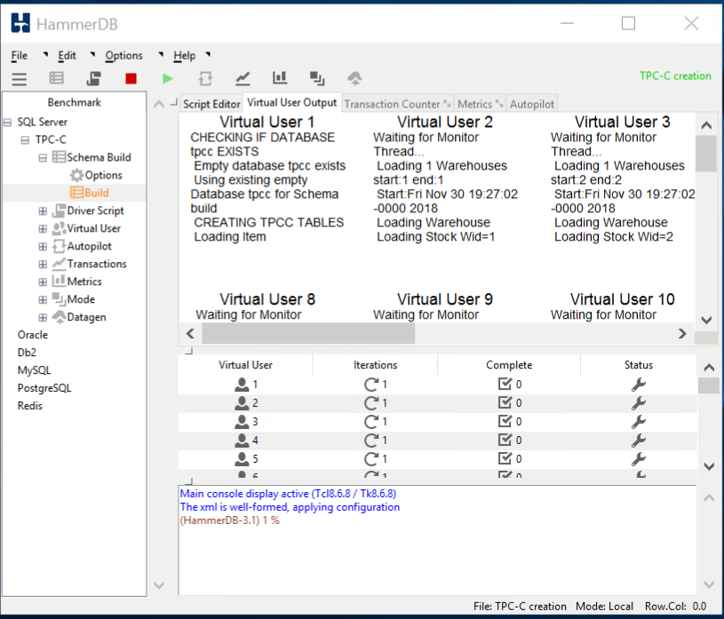

When the test is running it should like this.

TIP: If you would like to run a second test you **must** first delete the database you created and recreate it. HammerDB will not run a test against a database that has data in it. When you run a test is fills the database with a bunch of sample data.

* From Azure Monitor,
  + Create a graph for the SQL Server Active Transactions and Percent CPU and pin to your Azure Dashboard
  + Note: I had to customize the dashboard once I pinned it to a new Azure Dashboard  
    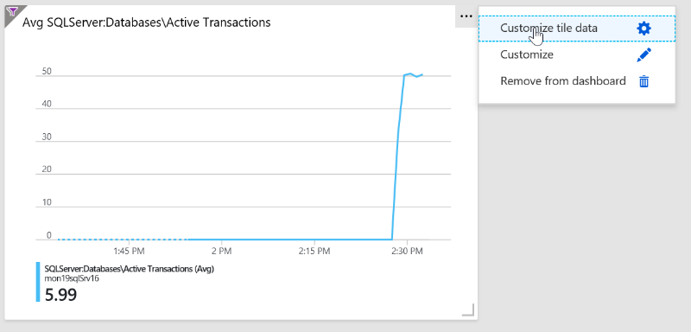

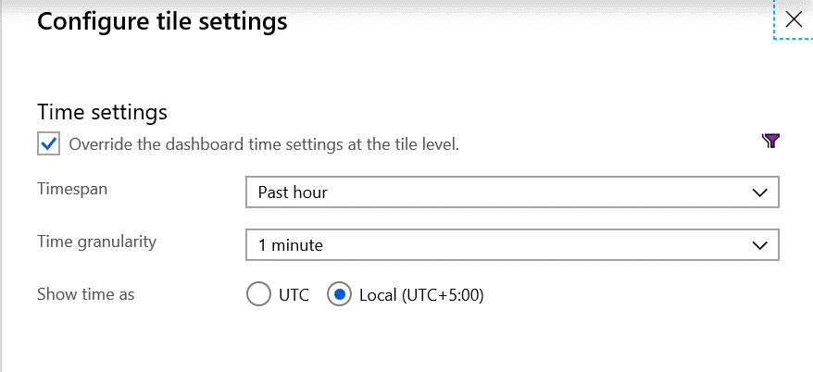  
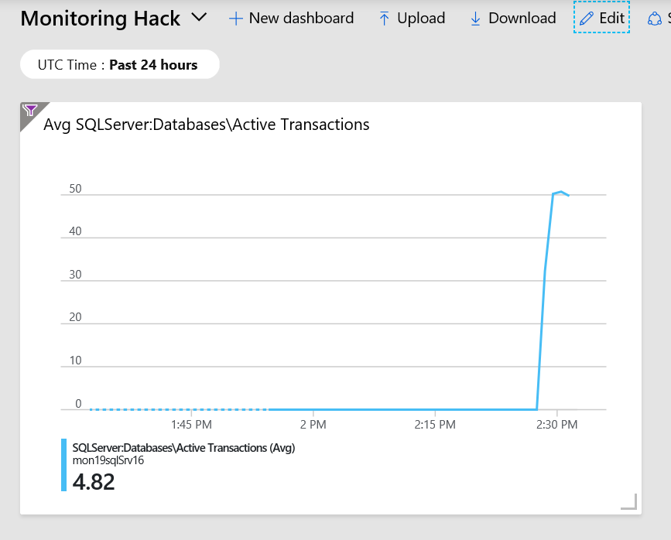

Dashboard should look something like this.

* + From Azure Monitor, create an Action group, to send email to your address

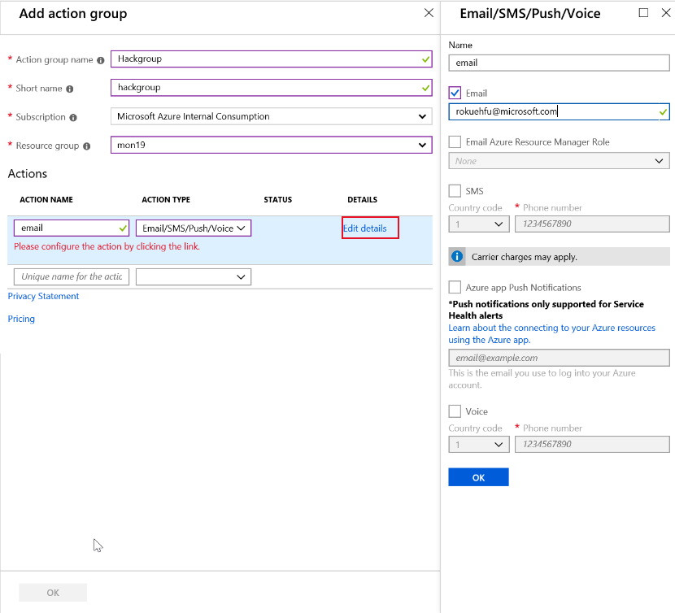

* + Create an Alert if Active Transactions goes over 40 on the SQL Server tpcc database.

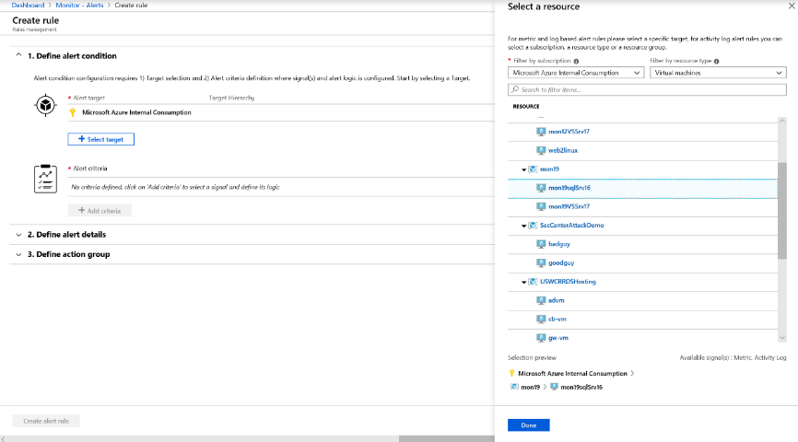

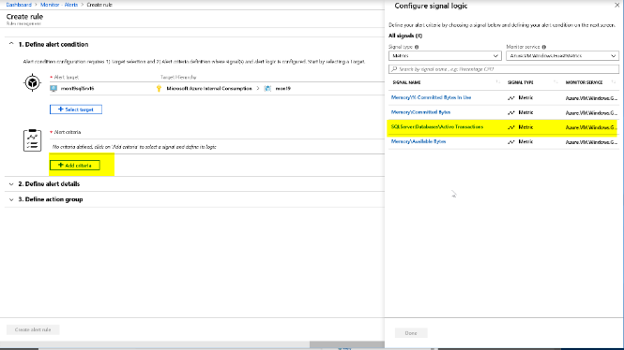

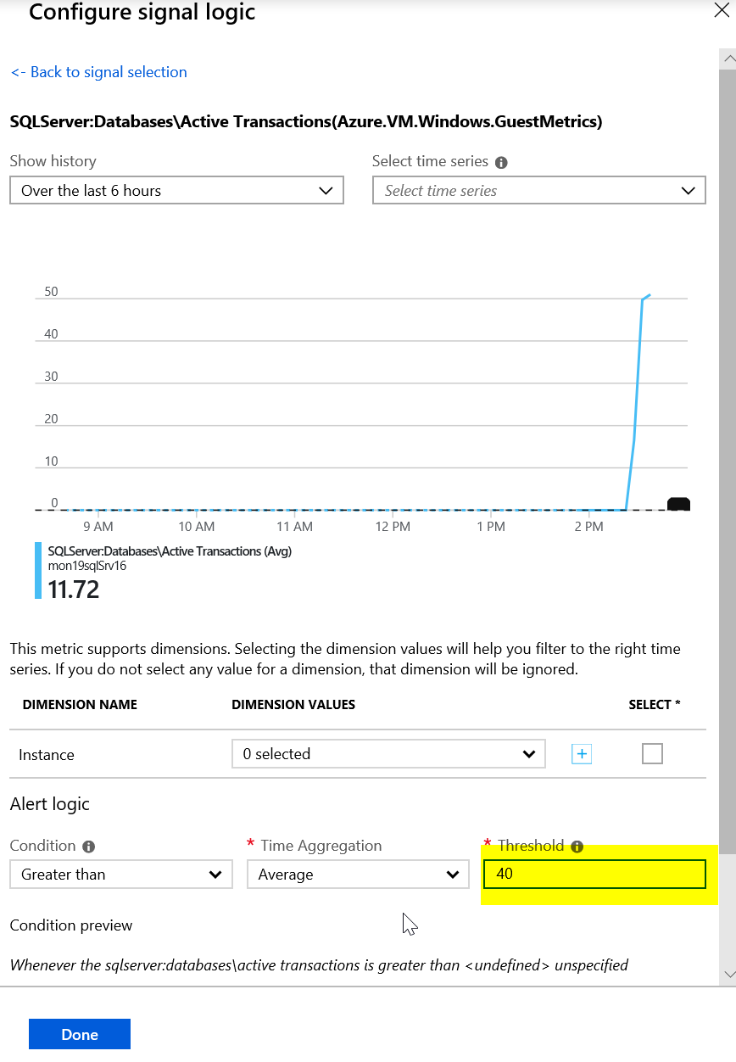

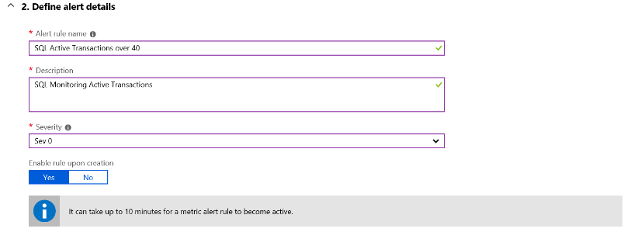

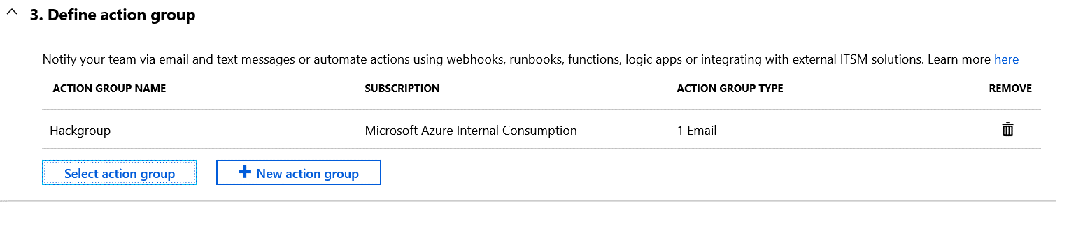



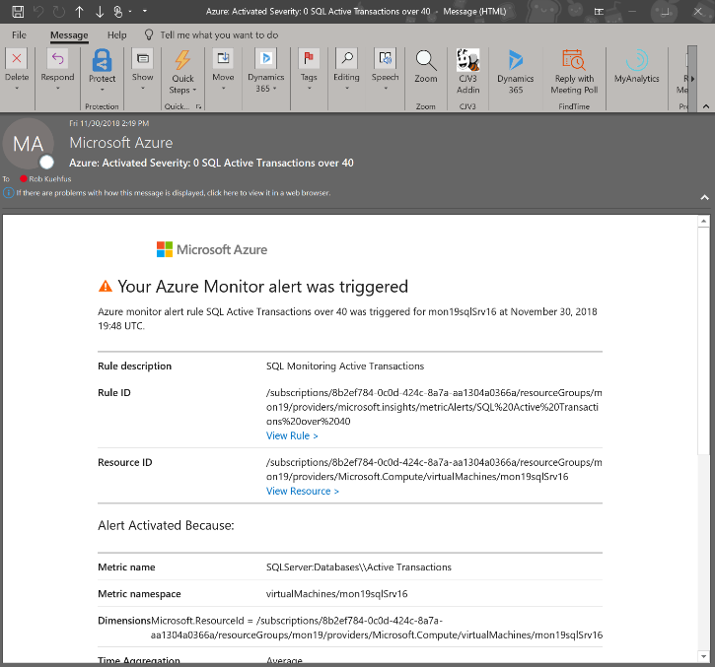

* Create an Alert Rule for CPU over 75% on the Virtual Scale Set that emails me when you go over the threshold.

First create a dashboard to watch the Scale Set CPU

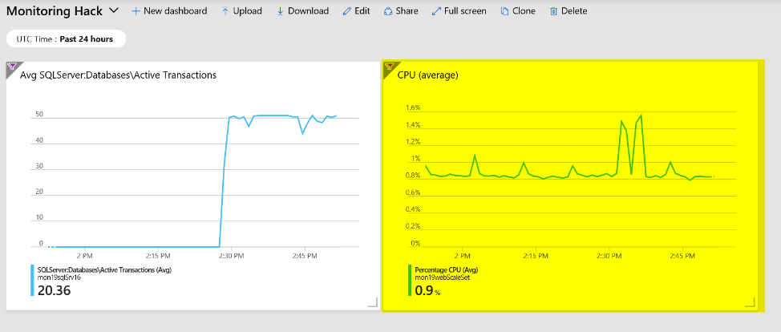

Navigate to the folder called “Loadscripts” under the Resources folder in Student and copy the cpuGenLoadwithPS.ps1 script to both instances running in the Scale Set and run them.

This may be a bit of a challenge to those not used to working with a scale set. If your student just grabs the public IP address and then RDP to it. They will end up on one of the instances but because they are going through the Load Balancer they cannot control which one. Or can they? 😊

If you look at the configuration of the LB it is configured with an inbound NAT rule that will map starting at port 50000 to each instance in the Scale Set. So if they RDP using the PIP:50000 for instance 1 and PIP:50001 for instance 2.

"inboundNatPools": [

{

"name": "natpool",

"properties": {

"frontendIPConfiguration": {

"id": "[concat(variables('webLbId'), '/frontendIPConfigurations/loadBalancerFrontEnd')]"

},

"protocol": "Tcp",

"frontendPortRangeStart": 50000,

"frontendPortRangeEnd": 50119,

"backendPort": 3389

}

}

],

For Example,

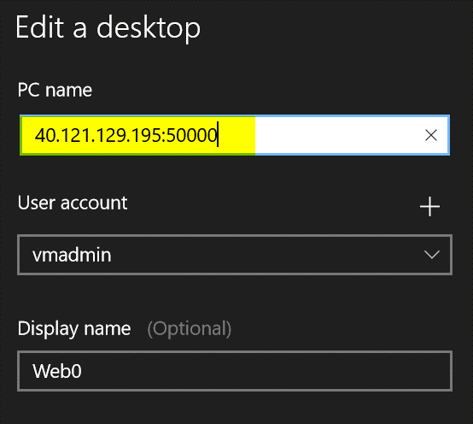

Jump on to both VMs in the Scale Set, Open the PowerShell ISE, Copy the script in the window and run it. You may need to run it more then once to really add the pressure. This script will pin each core on the VM no matter how many you have.

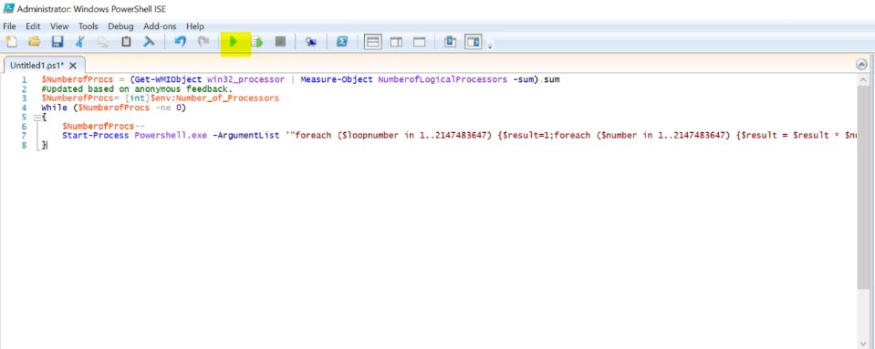

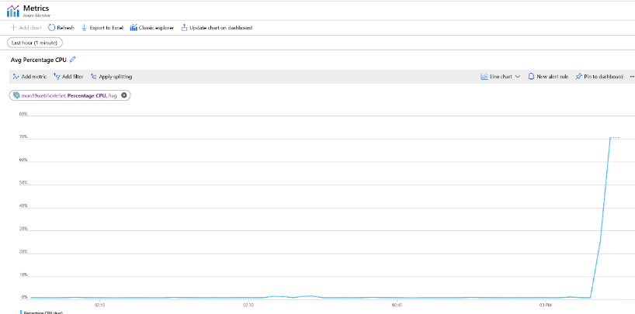

The trick to getting the alert to fire is to pin both instances at the same time as the CPU metric is an aggregate of the scale set. If you just max the CPU on one server to 100% the Scale Set is only at 50% and till not trip the alert threshold of 75%. Also, if they run the script and then setup the Alert Rule then to back to run another test to trip the alert, they have scaled out to a third instance and not realized it. They may need to jump on that box and max it out as well.

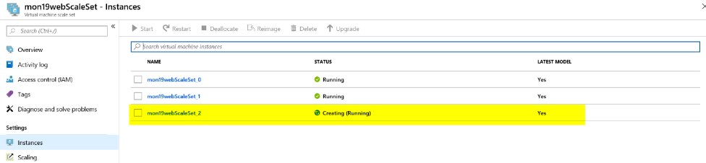

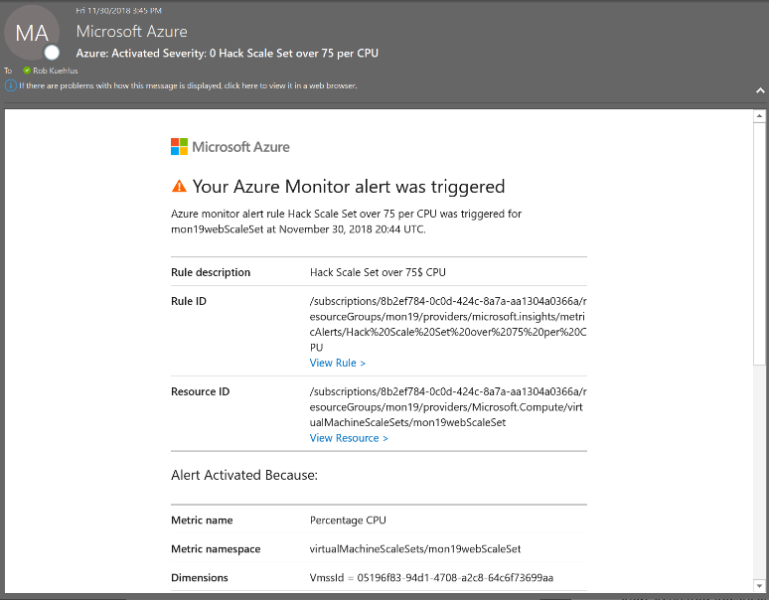

* First team to send me both alerts wins the challenge!!
* Good luck!

# Day 1: Monitoring and Alert Rule Automation Challenge

* Update the parameters file and deployment script for the GenerateAlertRules.json template located in the AlertTemplates folder
  + Add the names of your VMs and ResouceId for your Action Group

To find the ResourceId for your Action group navigate to the Resource Group where you are stored the action group and make sure to check off “Show hidden types”.

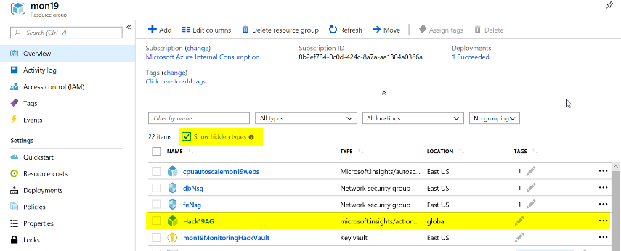

Click on your Action Group and copy the ResourceId

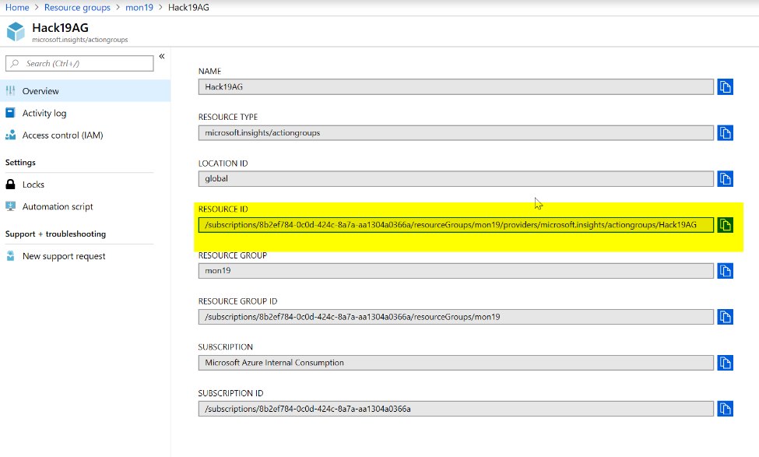

Then update the deployAlertRules.parameters.json file as it shows below.

Or

In the deployAlertRulesTemplates.ps1 script update the resourcegroup and run the first few lines then run the code to get the Azure Monitor Action Group

#Get Azure Monitor Action Group

Get-AzureRmResource -ResourceType 'Microsoft.Insights/actiongroups' | Select-Object Name, ResourceId

Copy and paste the resource Id for the Action Group you would like to use.

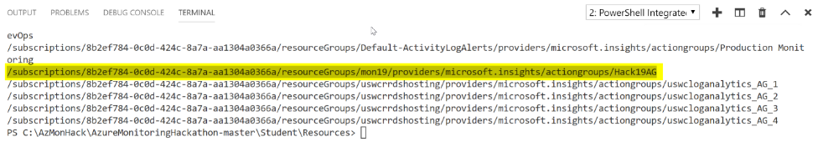

Save the parameters file and update the deployAlertRulesTemplate.ps1 file with the name of your Resource Group (and save it).

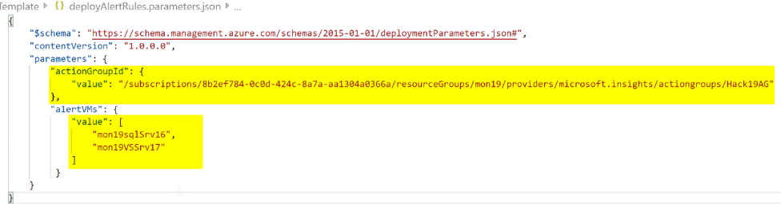

* Deploy the GenerateAlertRules.json template using the sample PowerShell script (deployAlertRulesTemplate.ps1) or create a Bash script (look at the example from the initial deployment)

#Update Path to files as needed

#Update the parameters file with the names of your VMs and the ResourceId of your Action Group (use command above to find ResourceId)

$template=".\AlertsTemplate\GenerateAlertRules.json"

$para=".\AlertsTemplate\deployAlertRules.parameters.json"

$job = 'job.' + ((Get-Date).ToUniversalTime()).tostring("MMddyy.HHmm")

New-AzureRmResourceGroupDeployment `

-Name $job `

-ResourceGroupName $rg.ResourceGroupName `

-TemplateFile $template `

-TemplateParameterFile $para

* Verify you have new Monitor Alert Rules in the Portal or from the command line (sample command is in the deployment script)

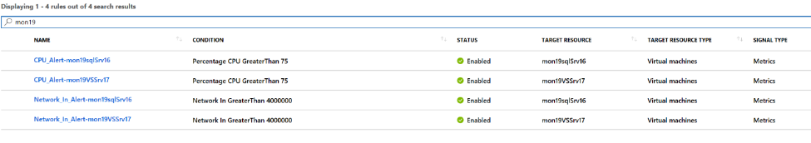

* Modify the GenerateAlertsRules.json to include “Disk Write Operations/Sec” and set a threshold of 10  
  **Tip:** Go here to view the list of metrics available by resource type - <https://docs.microsoft.com/en-us/azure/monitoring-and-diagnostics/monitoring-supported-metrics#microsoftcomputevirtualmachines>

Use this link to see the ARM schema - <https://docs.microsoft.com/en-us/rest/api/monitor/metricalerts/update>

{

"type": "Microsoft.Insights/metricAlerts",

"name": "[concat('Disk_Write_Alert','-',parameters('alertVMs')[copyIndex()])]",

"copy": {

"name": "iterator",

"count": "[length(parameters('alertVMs'))]"

},

"apiVersion": "2018-03-01",

"location": "global",

"tags": {},

"scale": null,

"properties": {

"description": "Disk Write metric has detected a large amount of disk operations",

"severity": "[parameters('alertSeverity')]",

"enabled": "[parameters('isEnabled')]",

"scopes": [

"[resourceId('Microsoft.Compute/virtualMachines', parameters('alertVMs')[copyIndex()])]"

],

"evaluationFrequency": "PT5M",

"windowSize": "PT5M",

"criteria": {

"odata.type": "Microsoft.Azure.Monitor.SingleResourceMultipleMetricCriteria",

"allOf": [

{

"name": "MetricDiskWriteOper",

"metricName": "Disk Write Operations/Sec",

"dimensions": [],

"operator": "GreaterThan",

"threshold": 10,

"timeAggregation": "Average"

}

]

},

"actions": [

{

"actionGroupId": "[parameters('actionGroupId')]",

"webHookProperties": {}

}

]

},

"dependsOn": []

},

* Rerun your template and verify your new Alert Rules are created for each of your VMs

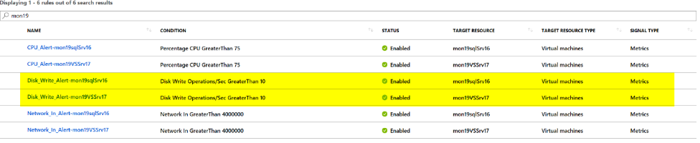

* First team to me a screenshot of the new Alert Rules wins the challenge!!
* Good luck!

# Day 2: Log Analytics Setup Challenge

* Create a new Log Analytics Workspace

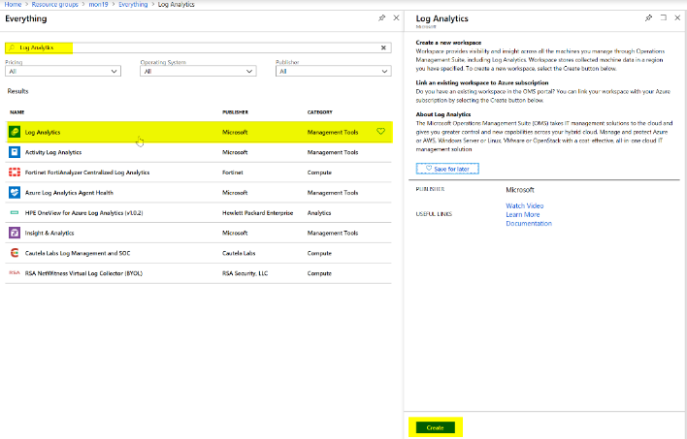

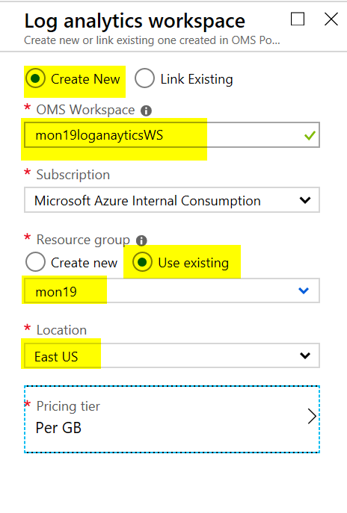

* + From the portal connect SQL Server to your workspace.

Navigate to your new workspace, click on the Virtual Machines, filter the list you the resource group you are using for the hack  
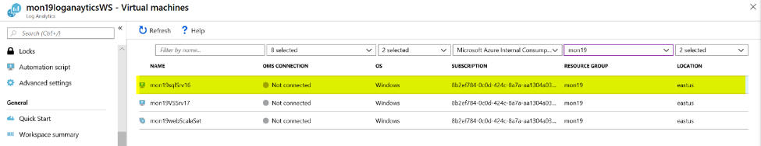

Click on the xxxxxsqlSrv16 server and click connect  
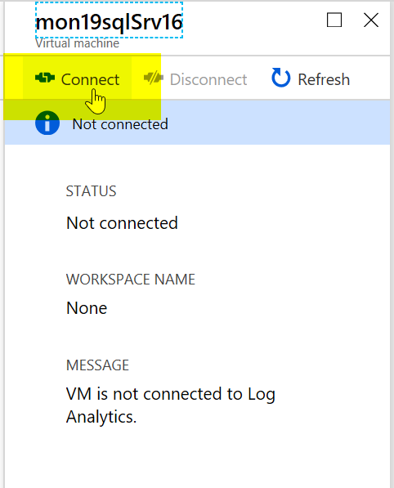

* + Modify the ARM template to automatically connect your VM Scale Set to the workspace. Then redeploy template and verify the Web and SQL servers are connected

Add a new parameter with a default -   
 "logAnalytics": {

"type": "string",

"defaultValue": "mon19loganayticsWS",

"metadata": {

"description": ""

}

},

Add this to the scale set extension -   
{

"name": "logAnalyticsPolicy",

"properties": {

"publisher": "Microsoft.EnterpriseCloud.Monitoring",

"type": "MicrosoftMonitoringAgent",

"typeHandlerVersion": "1.0",

"autoUpgradeMinorVersion": true,

"settings": {

"workspaceId": "[reference(resourceId('Microsoft.OperationalInsights/workspaces',parameters('logAnalytics')), '2015-03-20').customerId]"

},

"protectedSettings": {

"workspaceKey": "[listKeys(resourceId('Microsoft.OperationalInsights/workspaces',parameters('logAnalytics')), '2015-03-20').primarySharedKey]"

}

}

},

Run the deployment again.   
Tip: In order to update a Scale Set you will need to navigate to the Scale Set Instances and Upgrade them.  
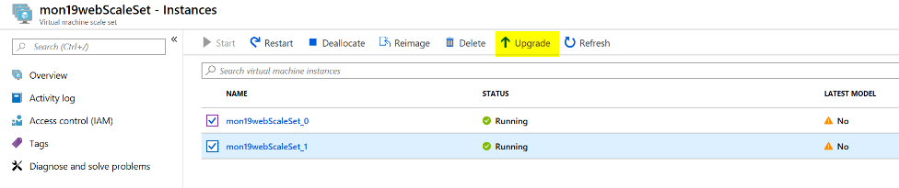

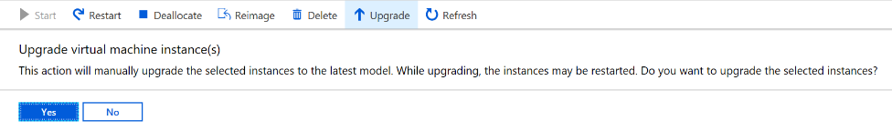

Verify the two nodes in the scale set and sql server are connected.  
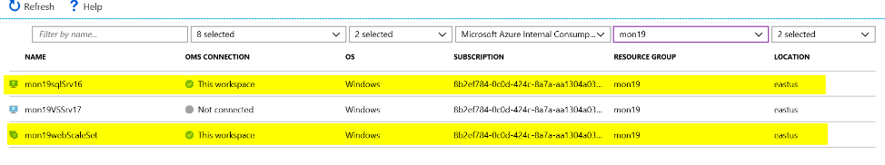

* + Connect the Azure Activity Log, NSG, LB, Key Vault and Storage Account (Events)

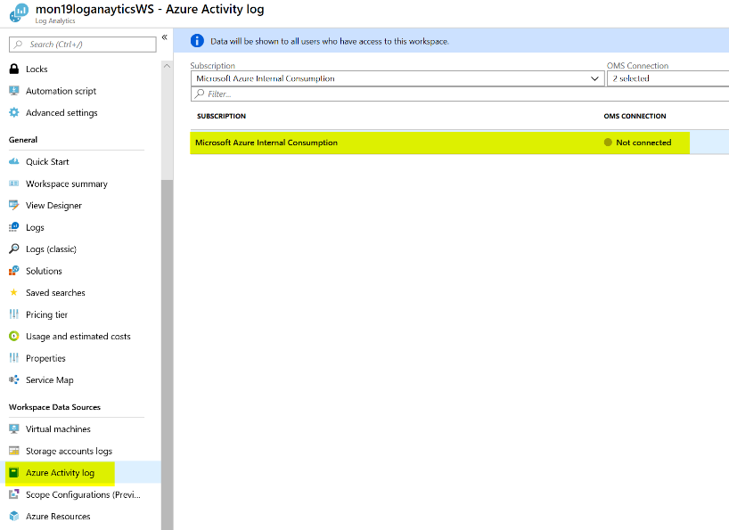

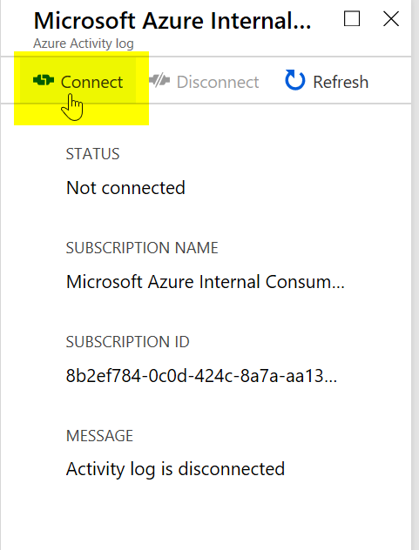

From Log Analytics, Workspace Data Sources, Storage accounts logs, click Add  
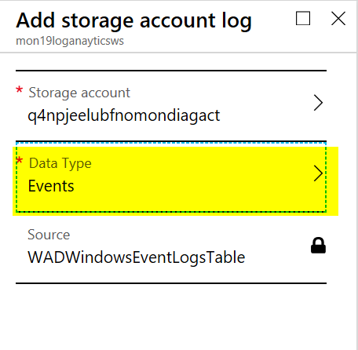  
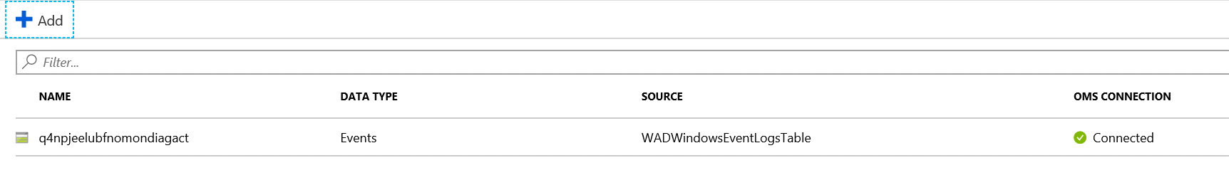

From Log Analytics, Workspace Data Sources, Azure Resources, filter the view to your resource group and connect the key vault, LB, and nsg(s).  
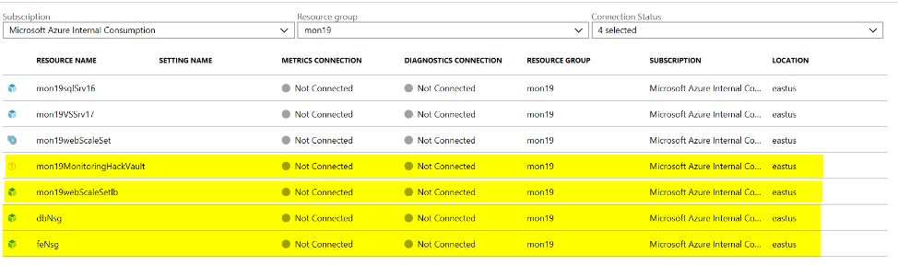

Key Vault – enter in a settings name  
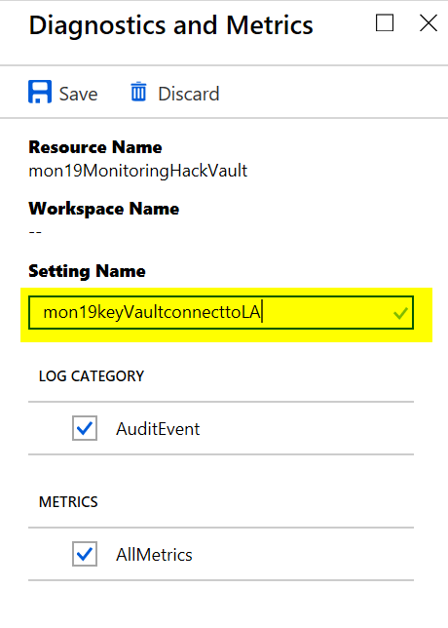

Load Balancer – enter a settings name  
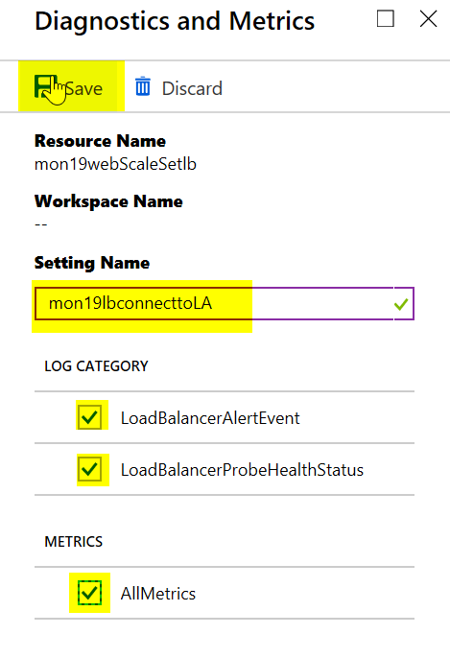

dbNSG and feNSG – enter a settings name  
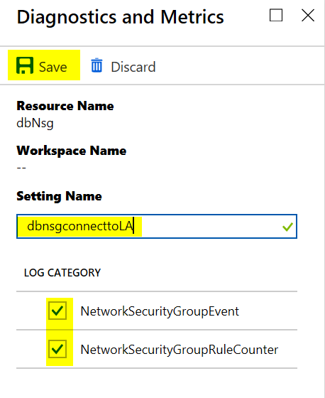  
Should look like this -   
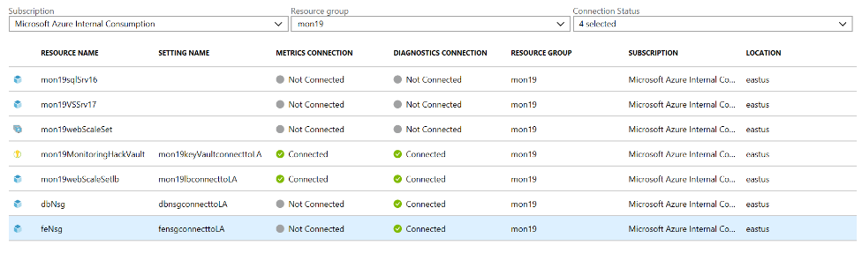

BTW…This does not need to be done through the Azure Portal. You can connect these resources in the ARM template. Here is a sample with the load balancer  
{

"type": "Microsoft.Network/loadBalancers/providers/diagnosticSettings",

"apiVersion": "2017-05-01-preview",

"name": "[concat(variables('webLbName'), '/', 'Microsoft.Insights/setByARM')]",

"location": "[resourceGroup().location]",

"dependsOn": [

"[resourceId('Microsoft.Network/loadBalancers', variables('webLbName'))]",

"[resourceId('Microsoft.Storage/storageAccounts', variables('storageAccountName'))]",

"LogAnalyticsDeployment"

],

"properties": {

"workspaceId": " [reference(resourceId('Microsoft.OperationalInsights/workspaces',parameters('logAnalytics')), '2015-03-20').customerId]

",

"metrics": [

{

"category": "AllMetrics",

"enabled": true,

"retentionPolicy": {

"enabled": false,

"days": "[parameters('retentionPolicy')]"

}

}

],

"logs": [

{

"category": "LoadBalancerAlertEvent",

"enabled": true

},

{

"category": "LoadBalancerProbeHealthStatus",

"enabled": true

}

]

}

},

* + Add the following solutions: Activity Log Analytics, Service Map, Key Vault, Agent Health, Azure SQL Analytics, and Network Performance Monitor.

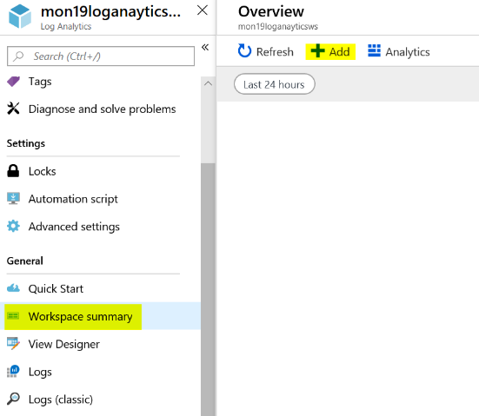

Select each of the solutions and add them  
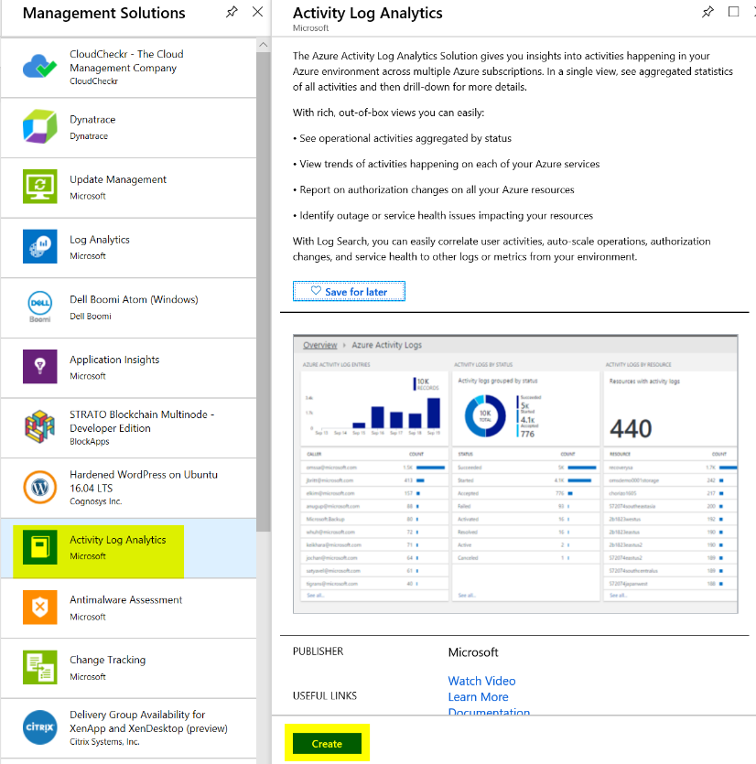

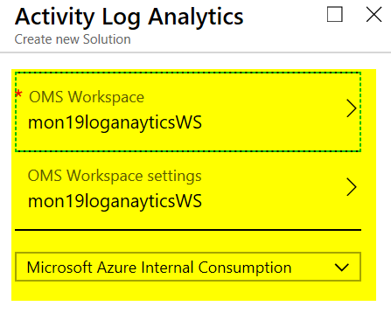

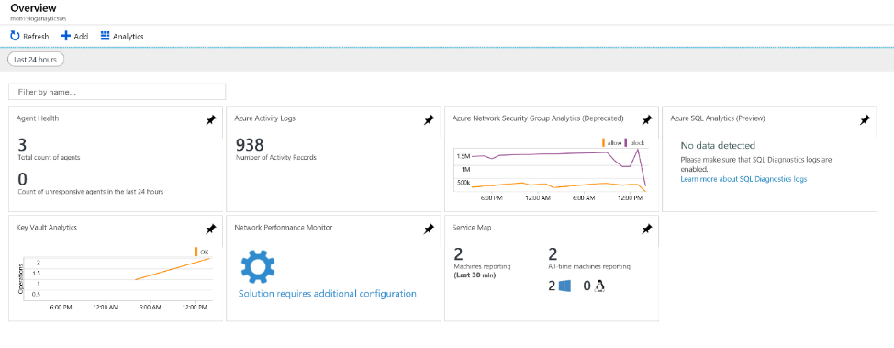

* + Add the standard performance counters, Application and System Event logs and IIS logs.

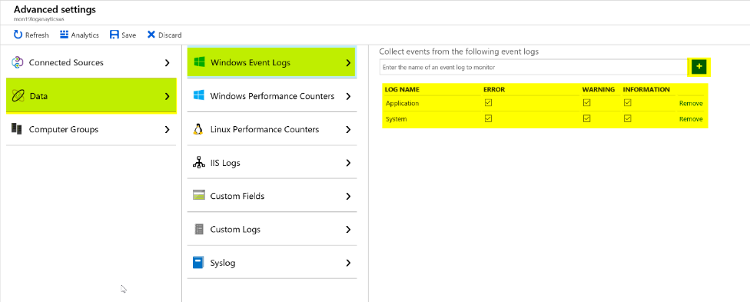

Type in Application and click the plus sign, repeat to add system.

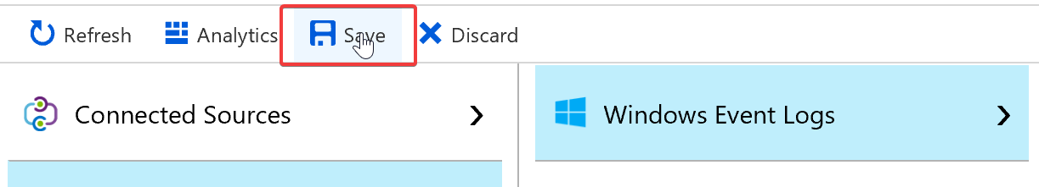

Make sure to Save the settings before moving on.

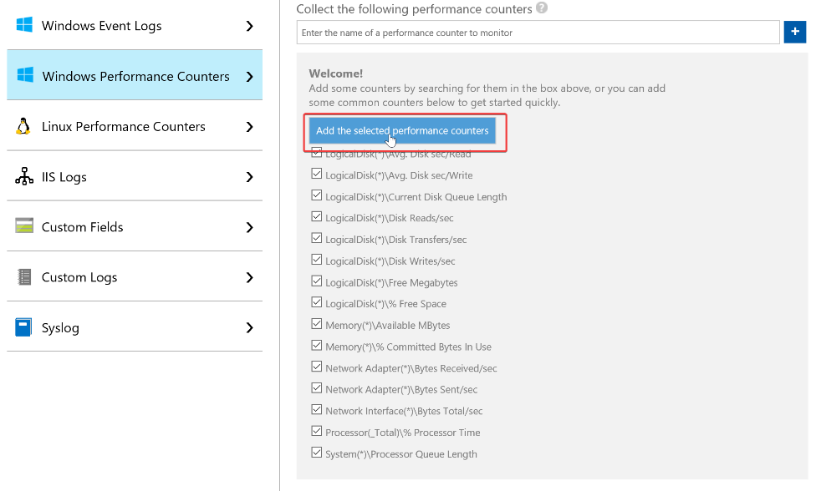

Click on the add the selected performance counters and make sure to click save

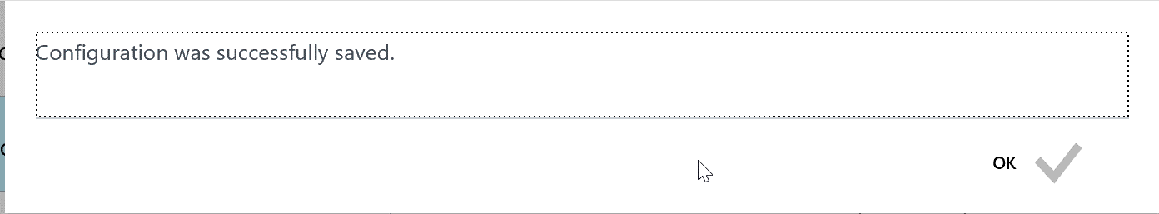

Click OK

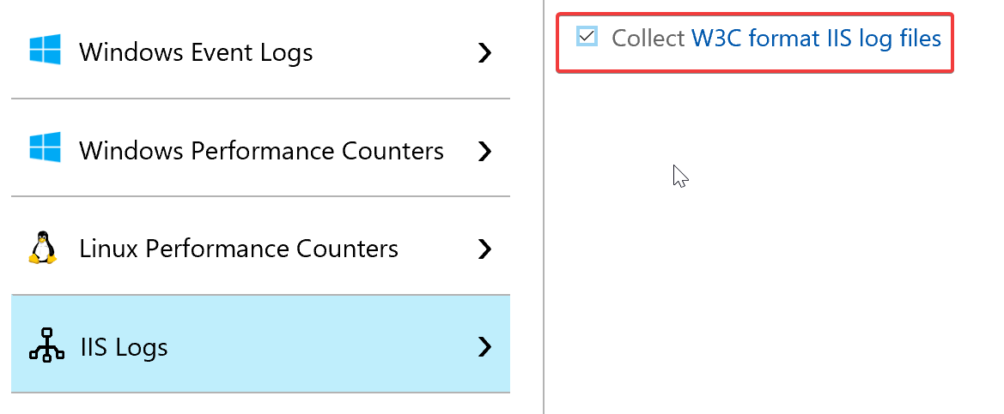

Check off the Collect… box and again remember to save your settings.

* Deploy Service Map agents to Web Scale Set VMs and SQL Servers

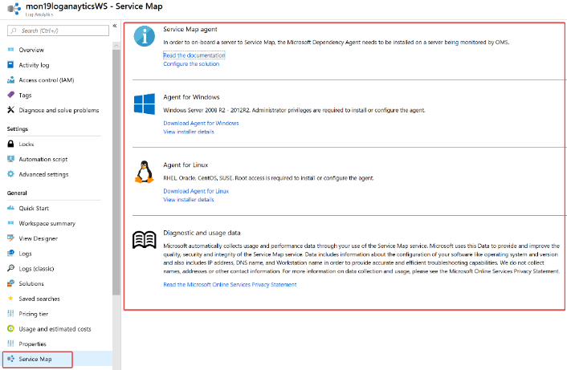

There are a number a ways this can be accomplished.

1. Log on to each VM, download the agent and install it
2. Download the agent, copy it to each VM and install it
3. Download the agent, copy it to an Azure Files share, log on to each VM and install the agent from the Azure File share
4. Update the ARM template with the Service Map extension, rerun the template deployment, upgrade the scale set

Here is the sample JSON for the extension:

VM

{

"type": "Microsoft.Compute/virtualMachines/extensions",

"name": "[concat(parameters('envPrefixName'), 'sqlSrv16/DependencyAgent')]",

"apiVersion": "2017-03-30",

"location": "[resourceGroup().location]",

"dependsOn": [

"[concat('Microsoft.Compute/virtualMachines/', parameters('envPrefixName'), 'sqlSrv16')]",

"[resourceId('Microsoft.Storage/storageAccounts', variables('storageAccountName'))]"

],

"properties": {

"publisher": "Microsoft.Azure.Monitoring.DependencyAgent",

"type": "DependencyAgentWindows",

"typeHandlerVersion": "9.4",

"autoUpgradeMinorVersion": true

}

},

Scale Set

{

"name": "DependencyAgent",

"properties": {

"publisher": "Microsoft.Azure.Monitoring.DependencyAgent",

"type": "DependencyAgentWindows",

"typeHandlerVersion": "9.4",

"autoUpgradeMinorVersion": true

}

},

* + Create a FE and BE group in Service Map

From the Log Analytics Workspace, click on Workspace Summary, Service Map  
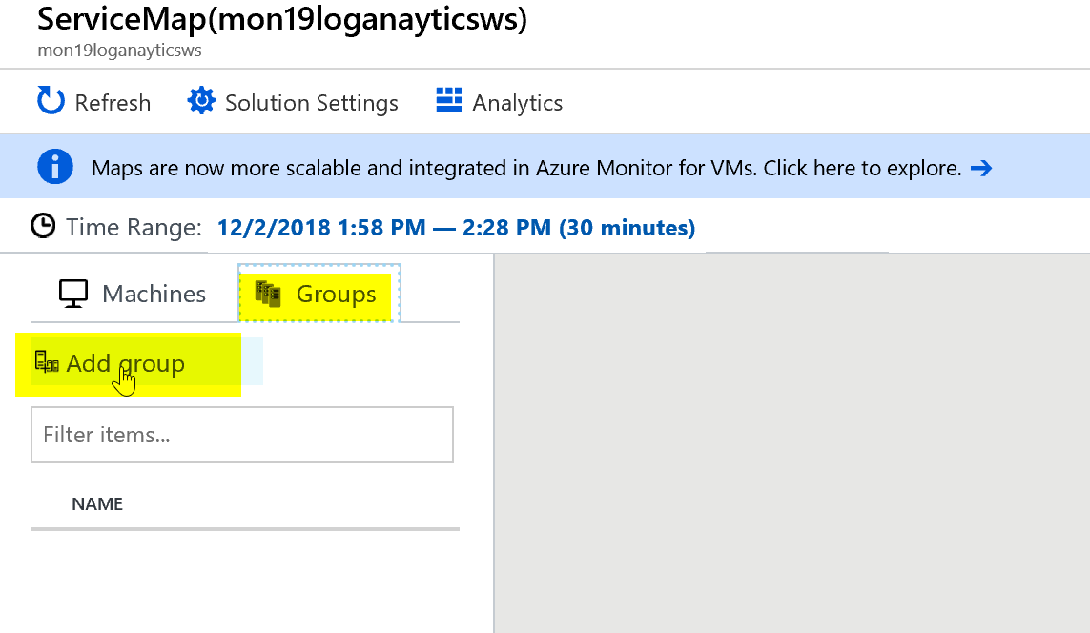

Enter the name for your Front End (FE) and Back end (BE) and hit enter for each one.

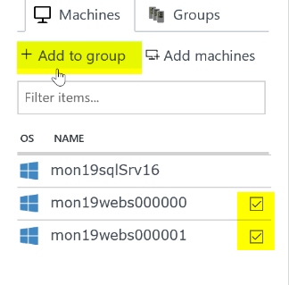

Click Add to group

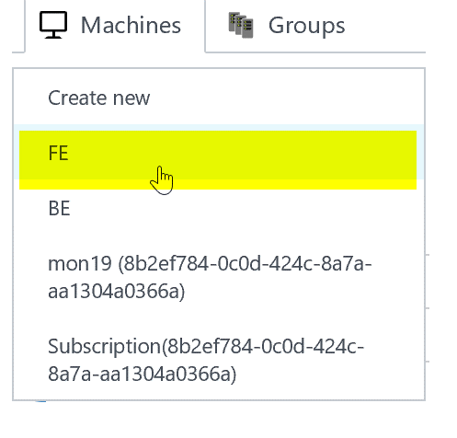

Click FE. Repeat to create back end group for SQL server.

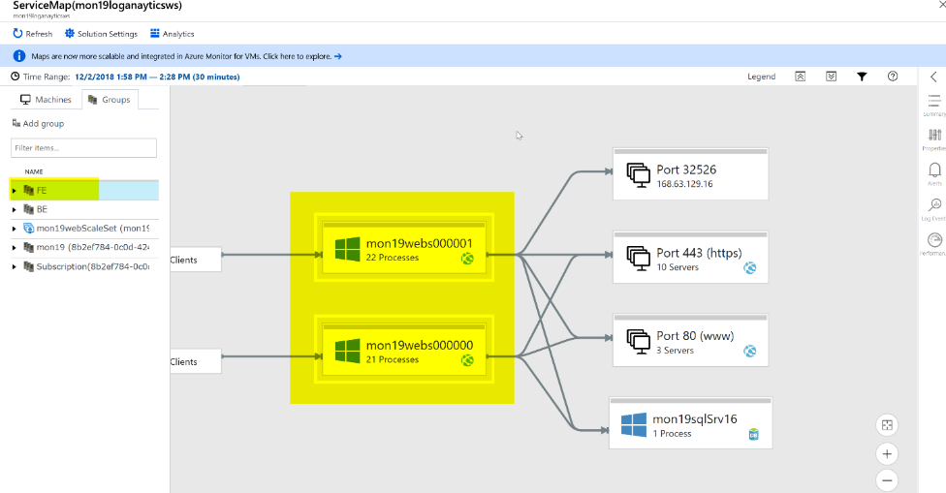

You can test it by going to Groups and clicking on FE and you should see some like this.

* + Generate DB load using HammerDB from the Visual Studio Server and view the results in Service Map

Tip: Make sure to delete the previous tpcc database before kicking off a new HammerDB test.

You should see the Visual Studio Server show up on the Server Map connecting to the SQL Server. This tells you there are additional VMs interacting with the database and may it was missed and should be monitored.

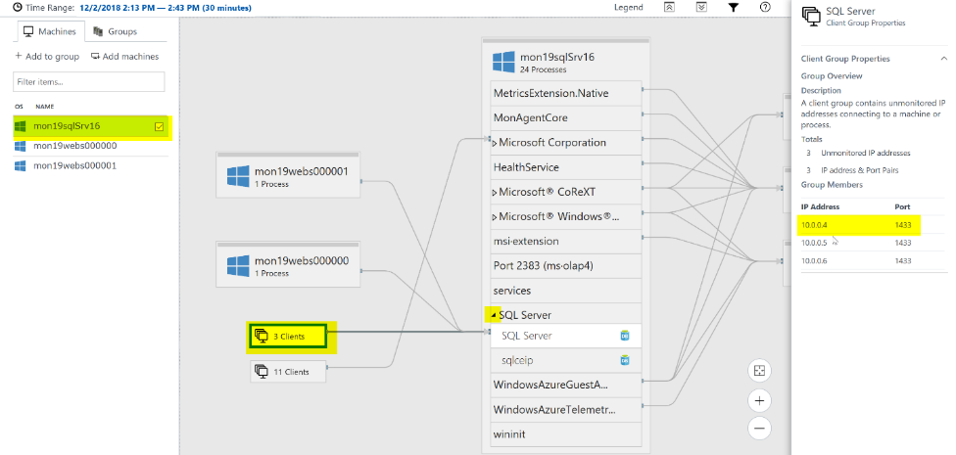

From Service Map, click on your Sql Server, drill into the SQL Server Process, Click on Clients and look to see if you an extra ip address besides the two web servers in the Scale Set. This shows an additional connection.

* First Team to email me a screenshot with the Visual Studio Server detected by your Scale Set and detected by Service Map wins the challenge. Good luck!

# Day 2: Log Analytics Dashboard Challenge

Write a performance query that renders a time chart for the last 4 hours for both of the Web Servers and the SQL Server for the following perf metrics. Save each query to your favorites.

* + Processor Utilization: Processor / % Processor Time

Perf

| where ObjectName == "Processor" and CounterName == "% Processor Time" and TimeGenerated > ago(4h)

| summarize AVGPROCESSOR = avg(CounterValue) by bin(TimeGenerated, 5m), Computer

| sort by AVGPROCESSOR desc

| render timechart

* + Memory Utilization: Memory / % Committed Bytes In Use

Perf

| where ObjectName == "Memory" and CounterName == "% Committed Bytes In Use" and TimeGenerated > ago(4h)

| summarize AVGMEMORY = avg(CounterValue) by bin(TimeGenerated, 5m), Computer

| sort by AVGMEMORY desc

| render timechart

* + Disk Utilization (IO): Disk Reads/sec and Disk Writes/sec

Perf

| where CounterName == "Disk Reads/sec" and ObjectName == "LogicalDisk" and TimeGenerated > ago(4h)

| summarize AvgReadsDiskIO = avg(CounterValue) by bin(TimeGenerated, 5m), Computer

| sort by AvgReadsDiskIO desc

| render timechart

Perf

| where CounterName == "Disk Writes/sec" and ObjectName == "LogicalDisk" and TimeGenerated > ago(4h)

| summarize AvgDiskWritesIO = avg(CounterValue) by bin(TimeGenerated, 5m), Computer

| sort by AvgDiskWritesIO desc

| render timechart

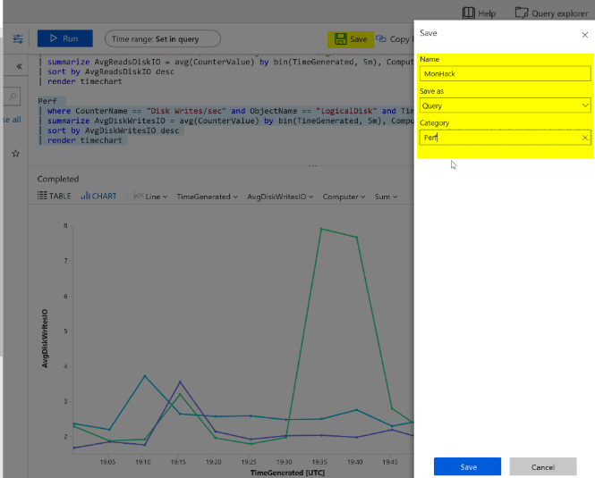

* Create a heartbeat query for Web and SQL Server

Heartbeat

| summarize max(TimeGenerated) by Computer

| where max_TimeGenerated < ago(15m)

| count

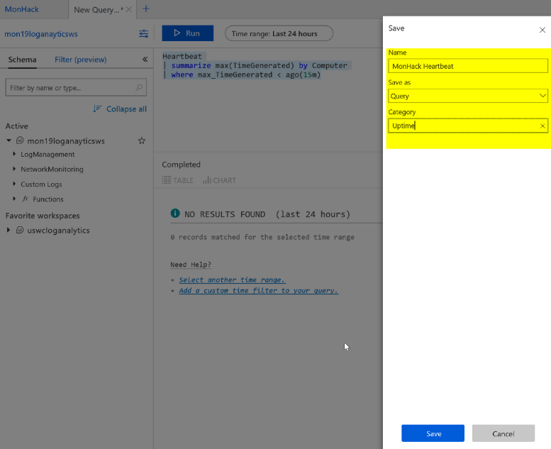

* Create a Log Analytics Solution
  + Use your heartbeat query for the Overview tile

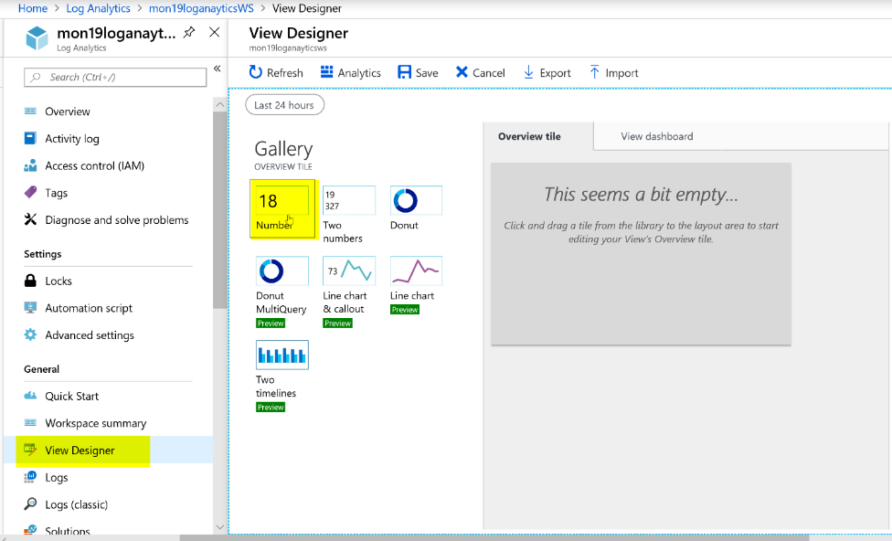

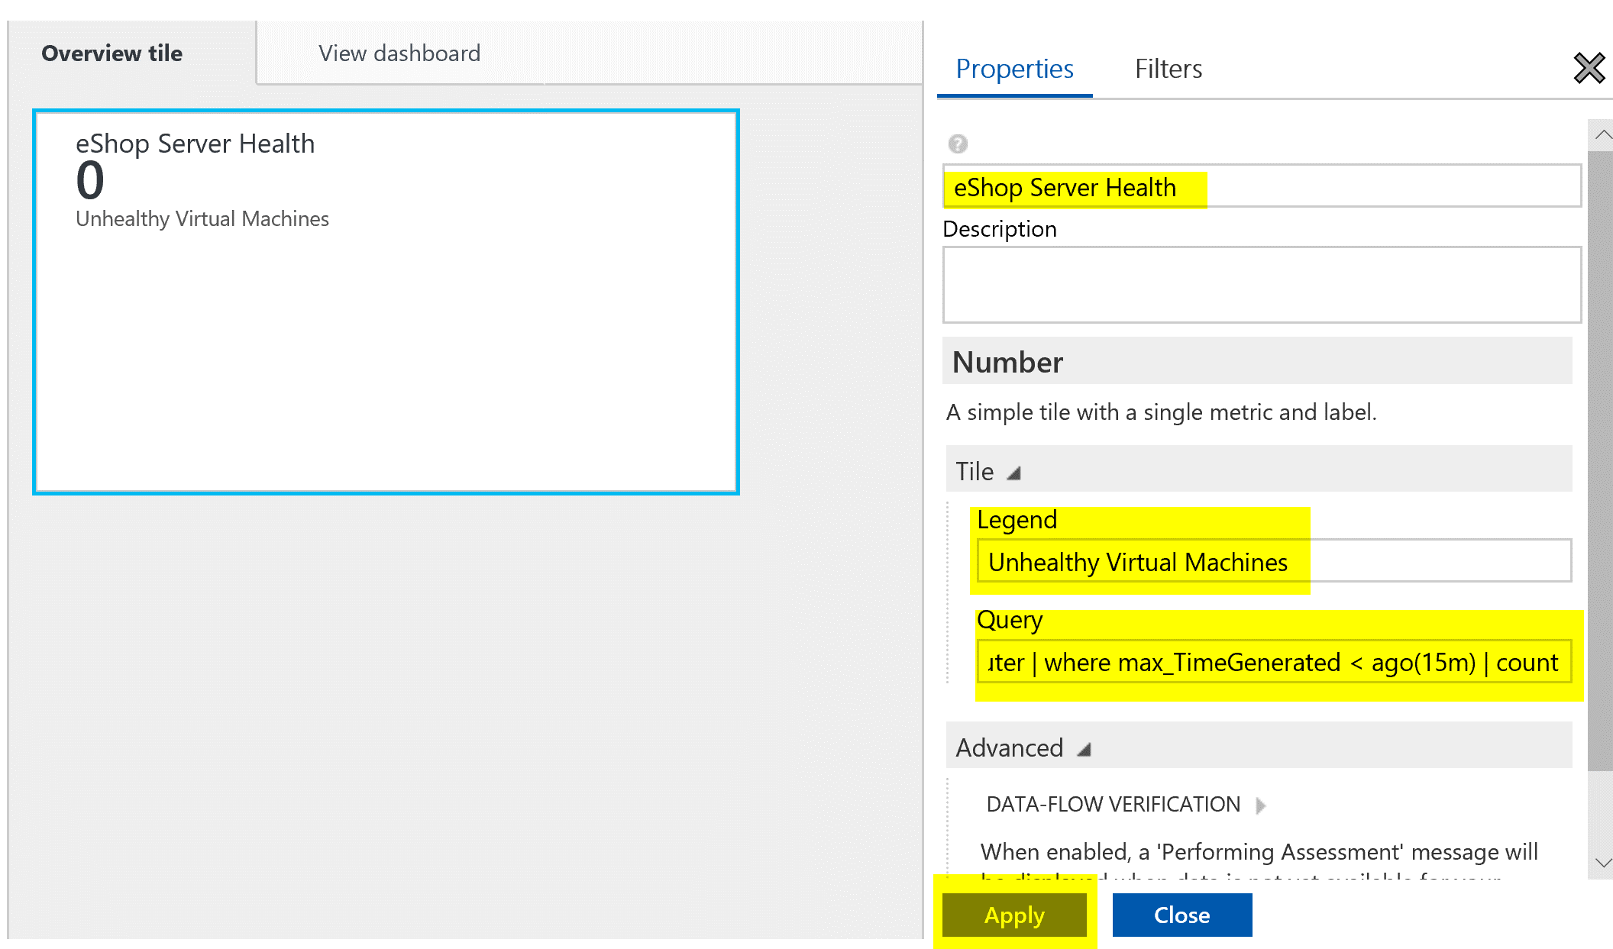

* + Use your performance queries to create a line chart & list for Processor, Memory and Disk (Reads & Writes).

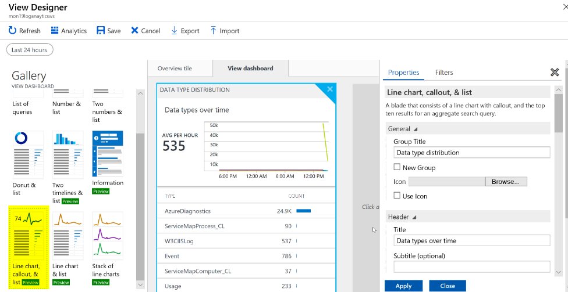

Select the Line, chart, callout & list. This one is nice because it has sparklines.

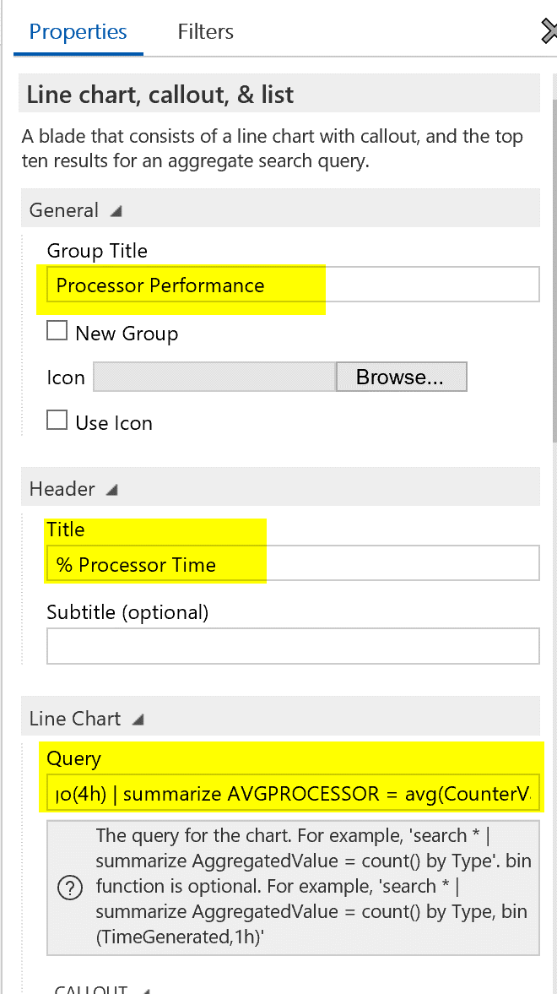

When building the charts make sure to modify your saved queries to look like this -   
Perf | where ObjectName == "Processor" and CounterName == "% Processor Time" and TimeGenerated > ago(4h) | summarize AVGPROCESSOR = avg(CounterValue) by bin(TimeGenerated, 5m), Computer

Tip: remove the sort line and render line for each query

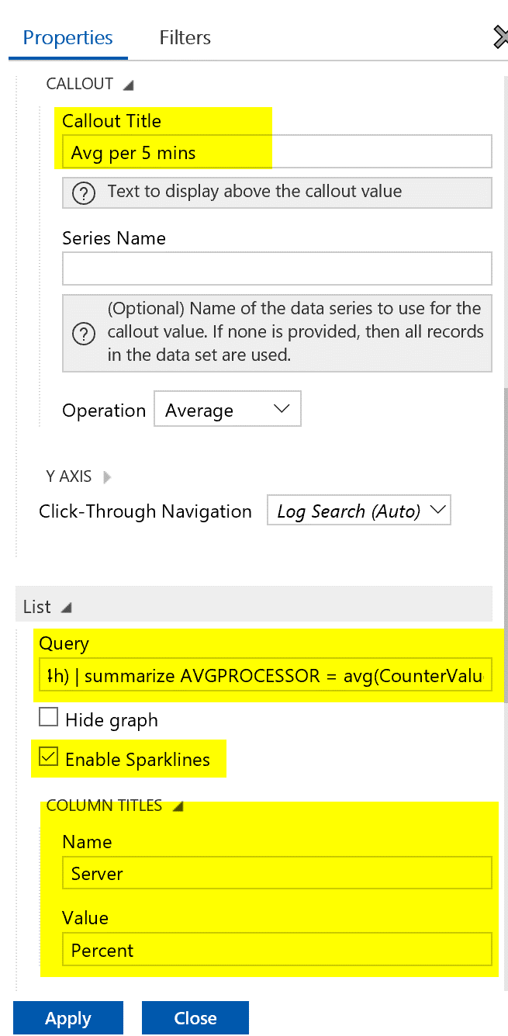

Make sure to update the Sparklines to something that makes sense for each graph.

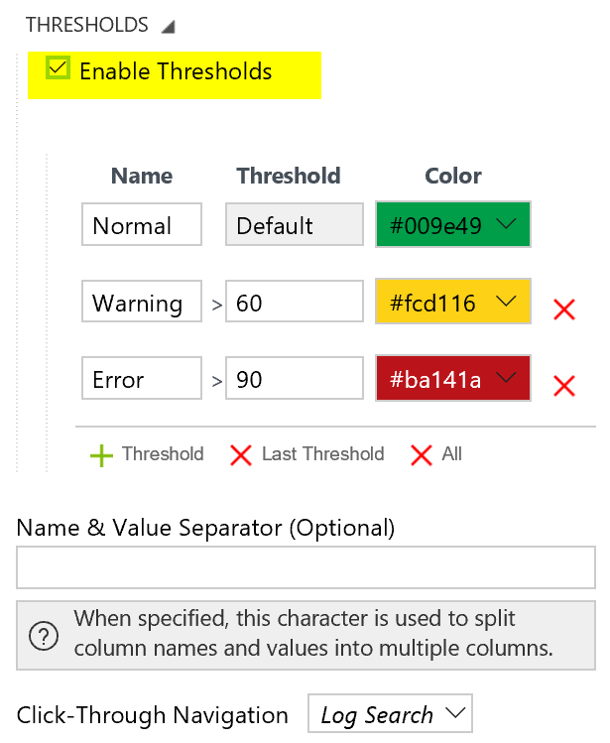

Set a threshold that makes sense.

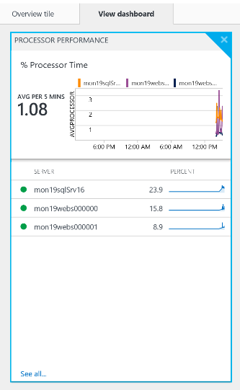

Should look like this when complete. Once you click apply you should see it refresh and look like this. Now save it and work your way through the other 3 performance metrics.

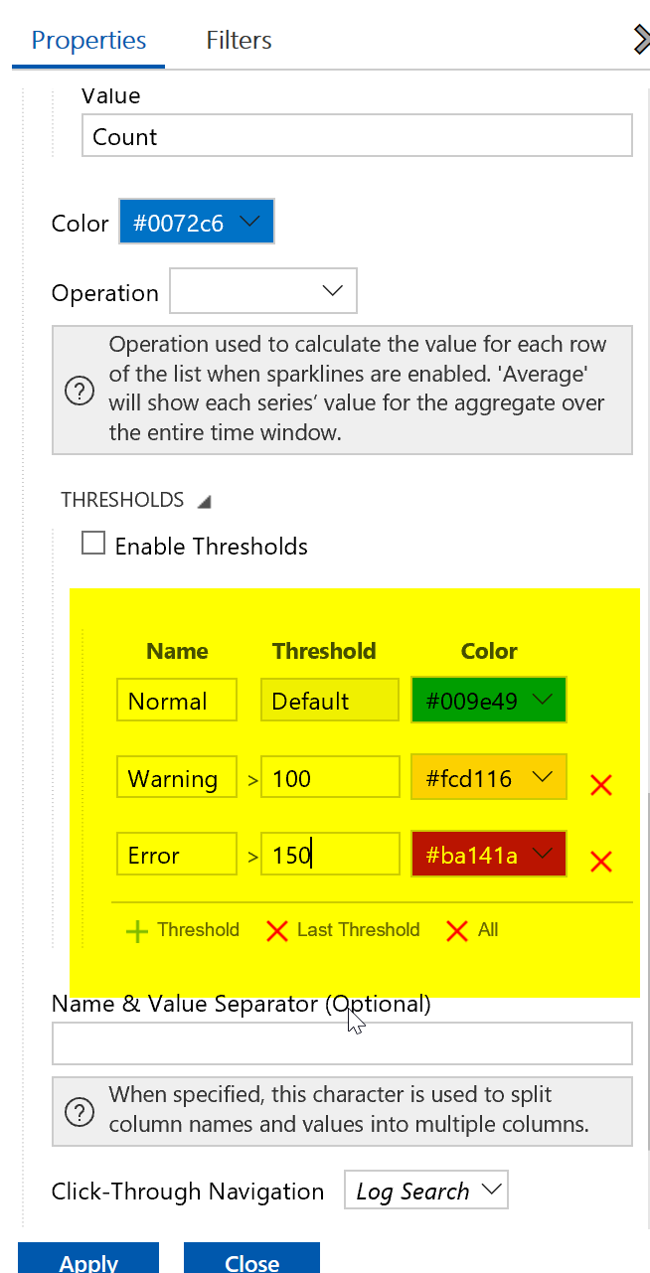

Disk Reads thresholds should be something like this.

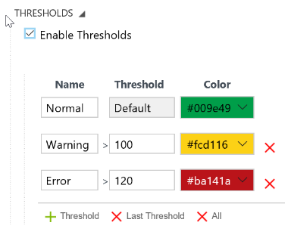

Disk Writes Threshold should be something like this.

* First Team to email me a screenshot with your Solution wins the challenge. Good luck!
* Final solution should look like this.

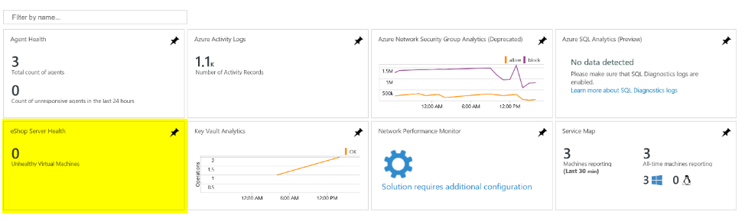

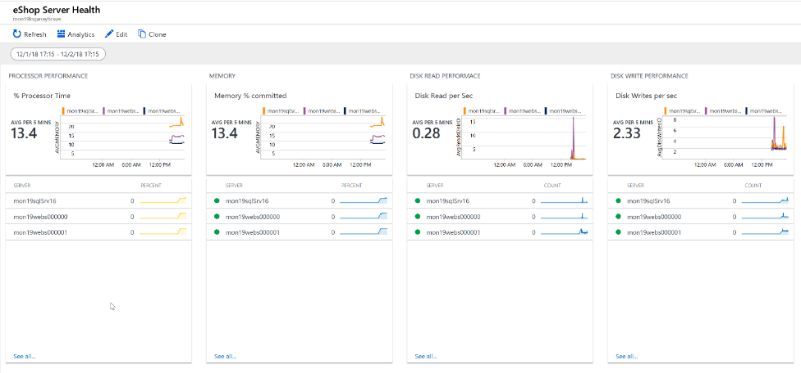

Tip: I have created the final solution in the students folder under resources Log Analytics Solution templates and the queries used are in the Loadscripts folder.

# Day 3: Application Insights Challenges

* Create an Application Insights Workspace

From the Azure Portal create a Application Insights Workspace,

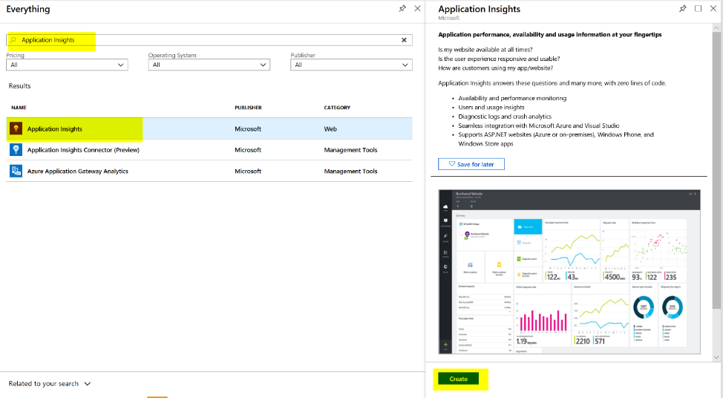

Enter a name, and leave it as an ASP.NET web application

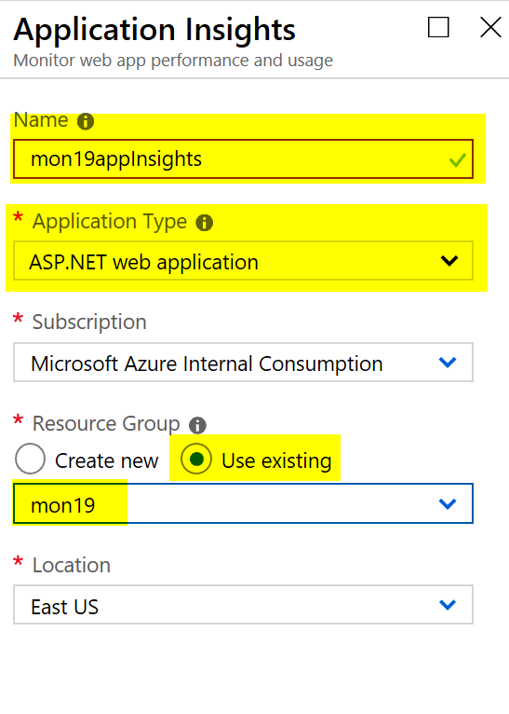

Keep it in the same Resource Group you have been using.

* In Visual Studio, Install the Application Insights SDK in the eShopOnWeb Web Project in the Solution

From the Visual Studio Server, navigate to C:\eshoponweb\eShopOnWeb-master and double-click on eShopOnWeb.sln

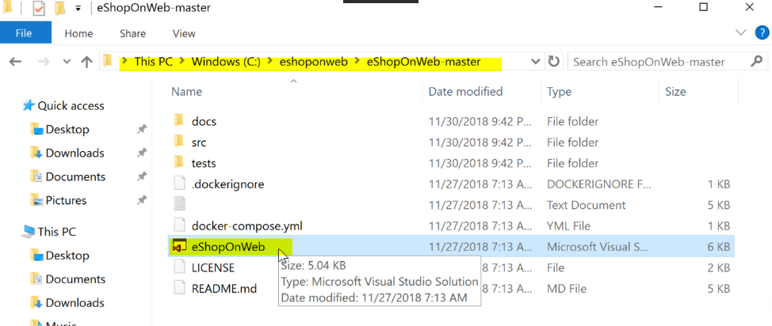

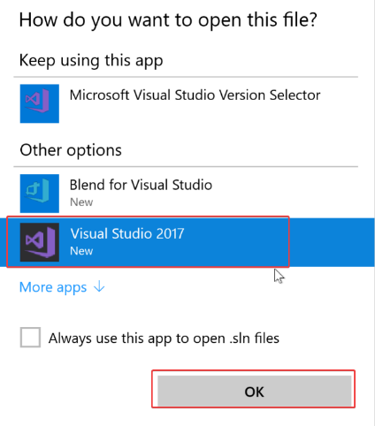

Select Visual Studio 2017 and click OK.

If this is the first time you are opening Visual Studio please log in or create an account and log in.

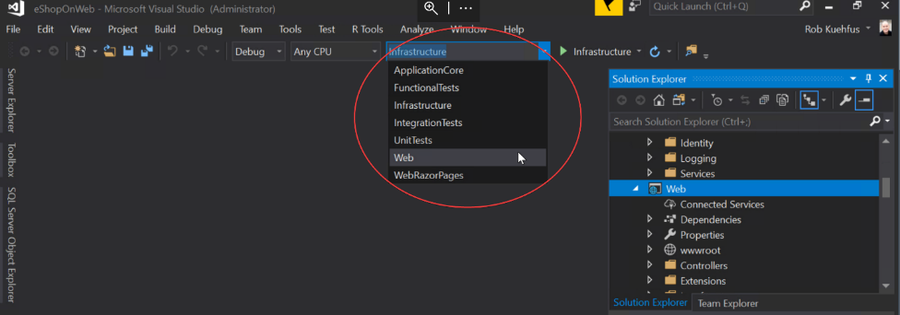

Select Web

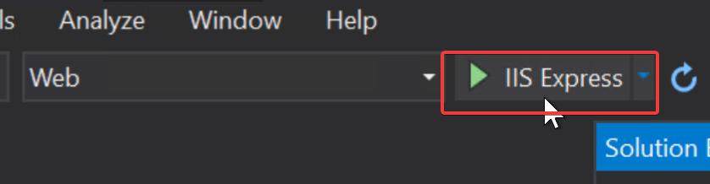

Click on IIS Express to test the eShop application



You should see the eShop app open locally. Close it and let’s add the Application Insights SDK

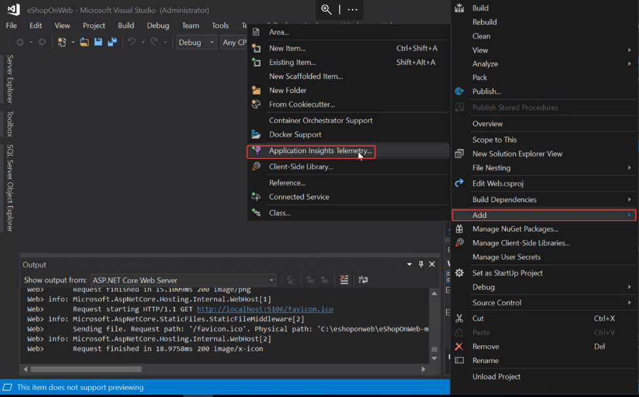

On the right hand side, find Web and right click, go to Add and select Application Insights Telemetry

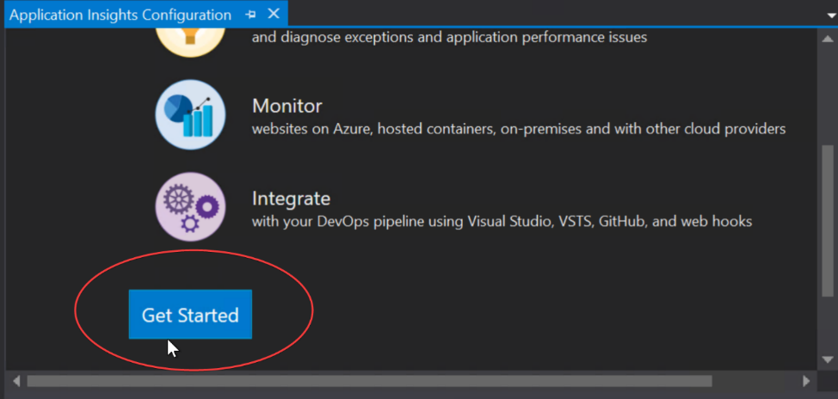

Click get Started

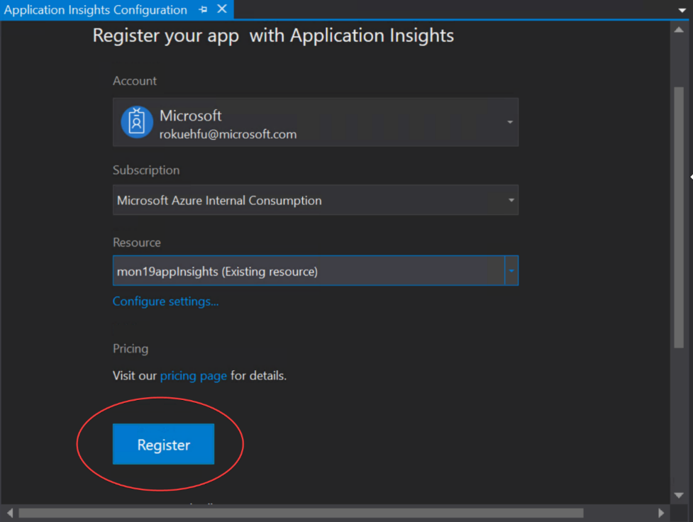

Select your subscription, Resource (name of your App Insights) and click Register.

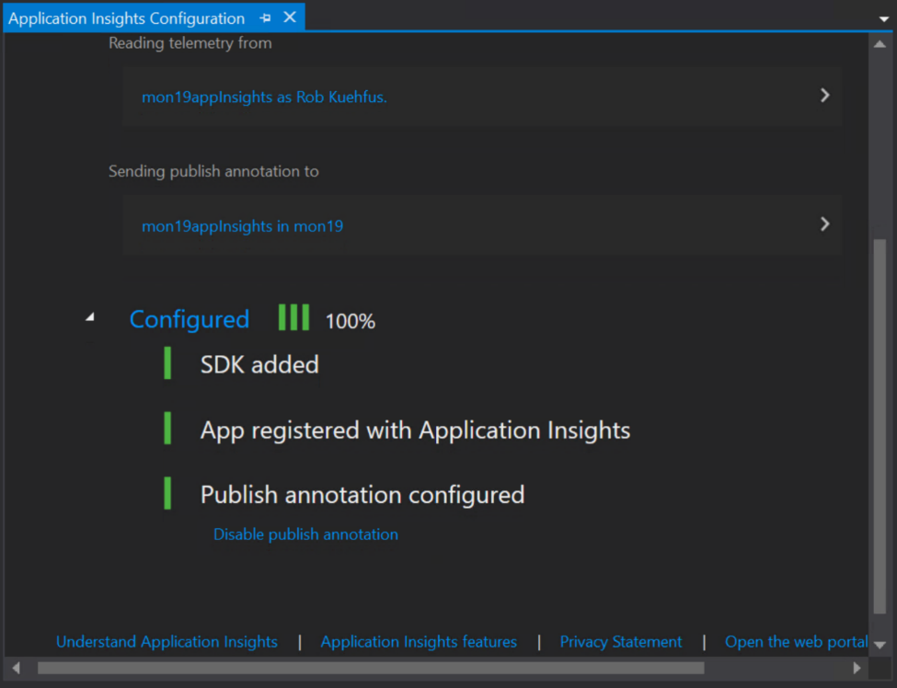

* + Run the eShopOnWeb Web project and check out the App Insights tooling

Test the application by running it and verify its working.

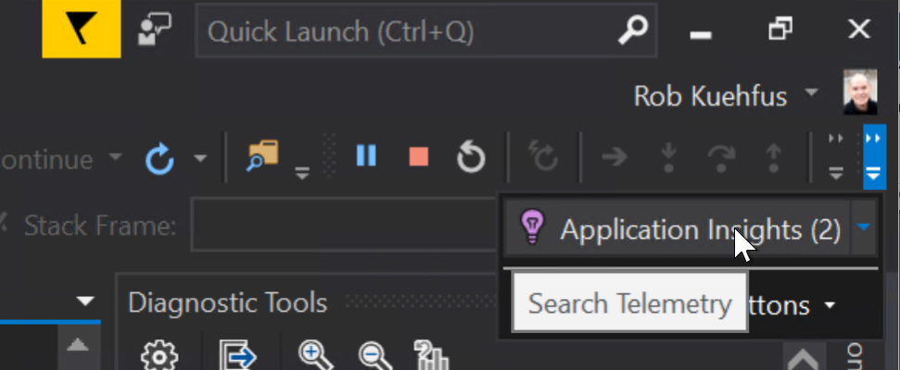

While its running you can navigate to Application Insights and view the telemetry while you are interacting with eShop running on the local machine. Add something to the shopping cart, log in and check out.

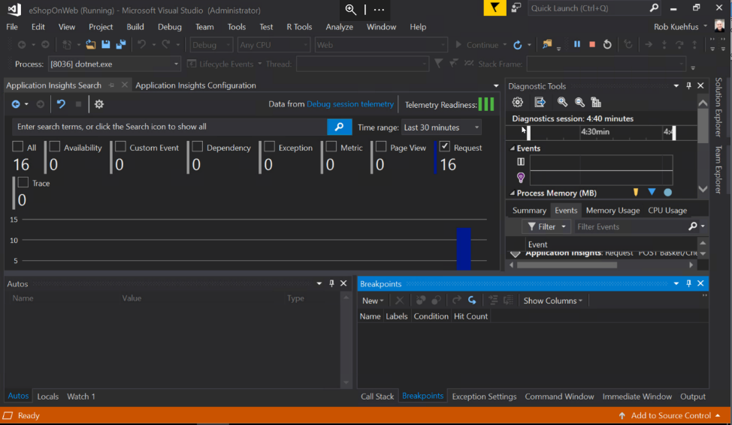

* + Add the updated Application Insights NuGet package to v2.5.1

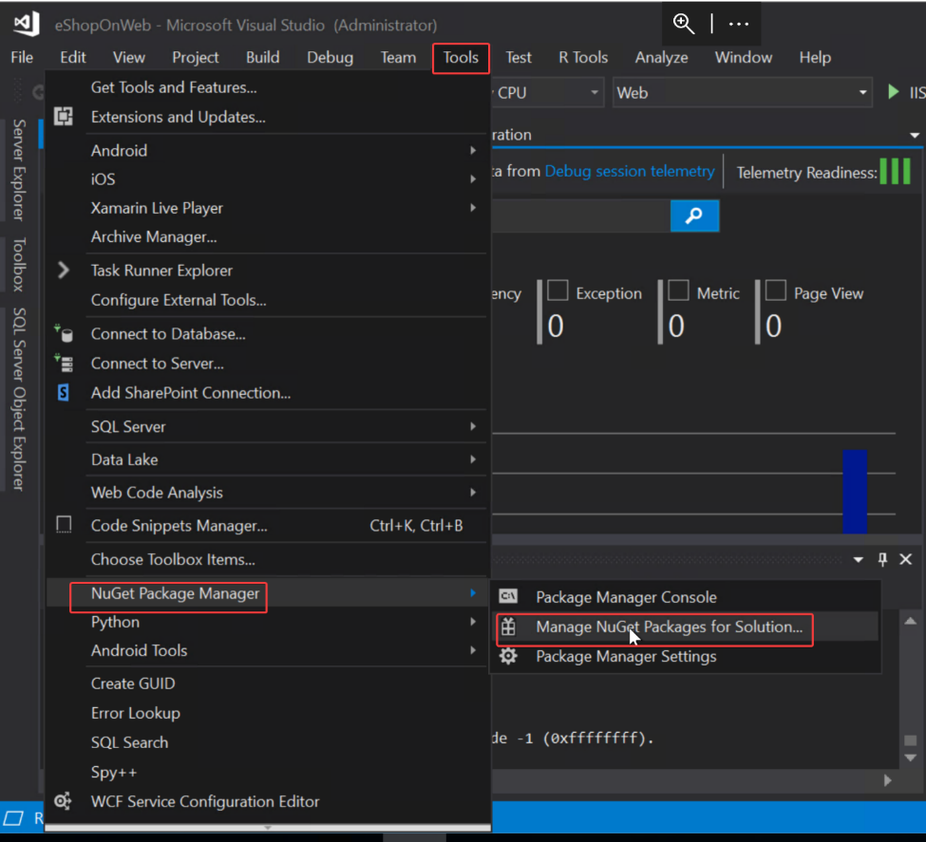

Go to Tools, NuGet Package Manager, Manage NuGet Packages for Solution

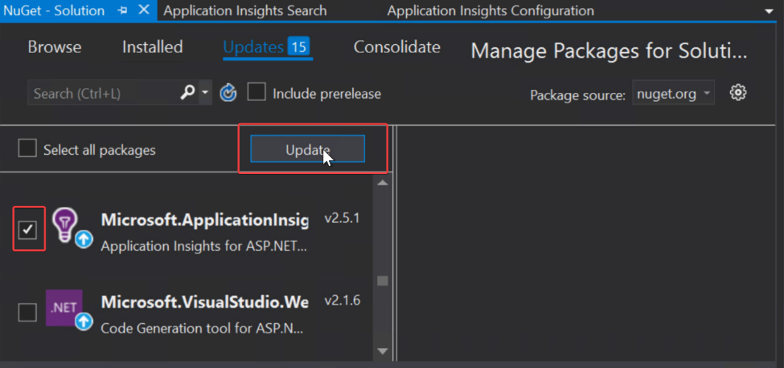

Check off the Microsoft.ApplicationInsights package (v2.5.1) and click Update

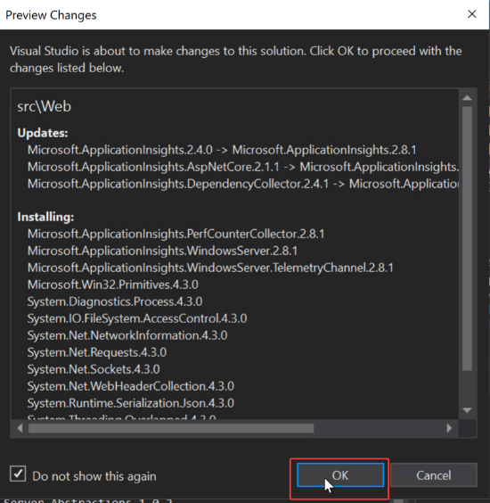

Click OK

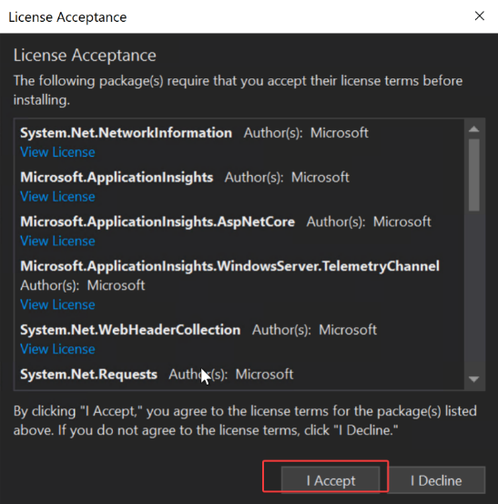

Click I Accept. When finished run the eShop application again to make sure it’s working.

* + Publish eShopOnWeb Web project to both Web Servers in the scaleset

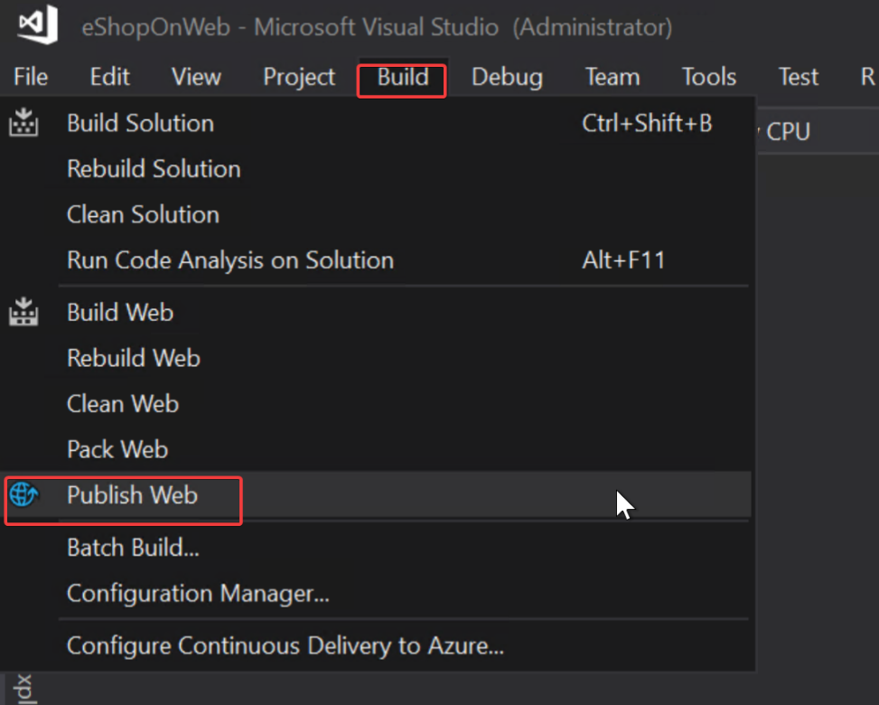

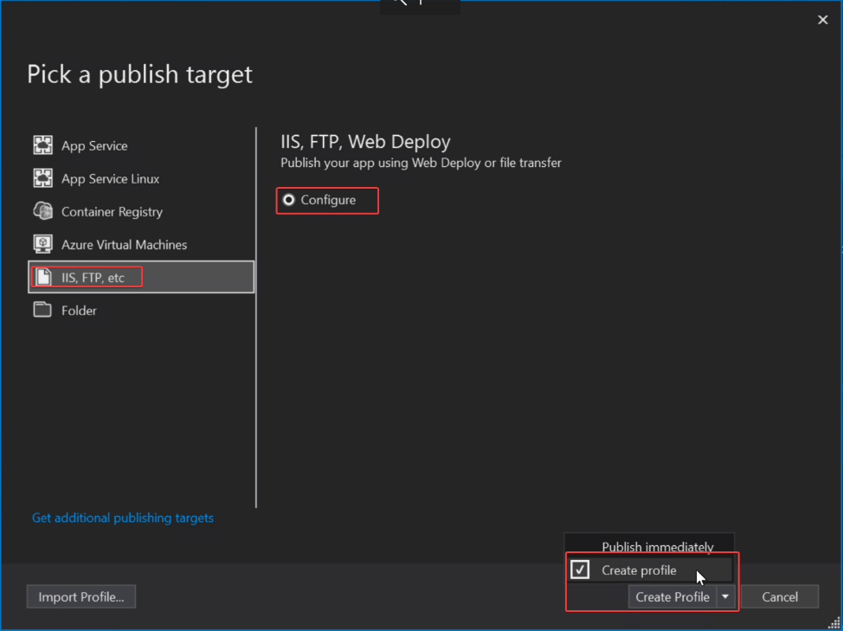

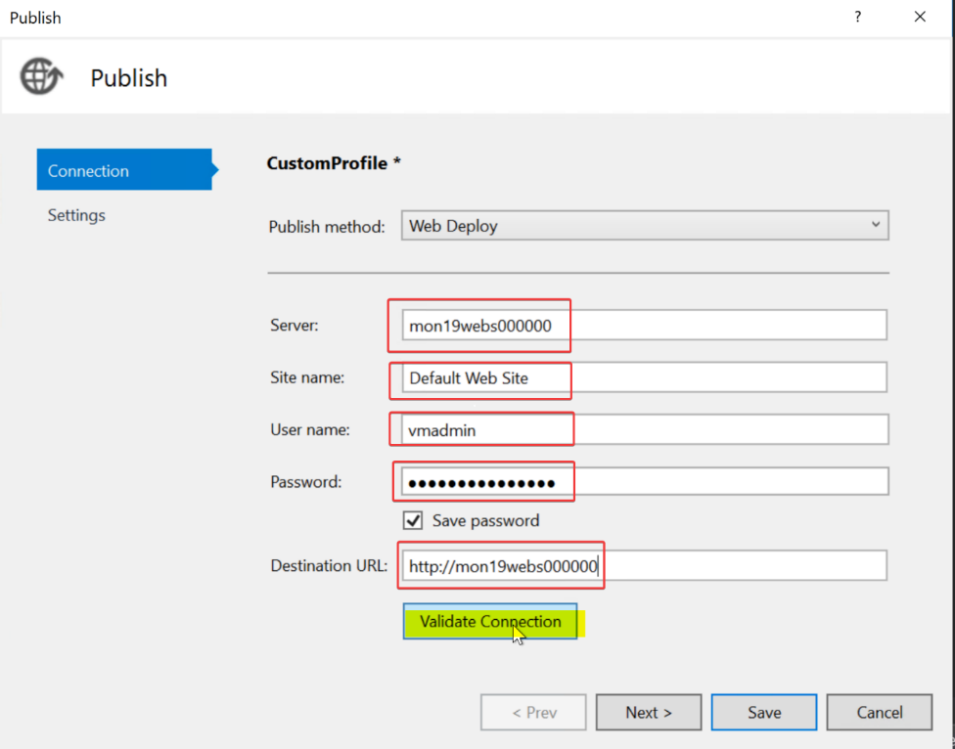

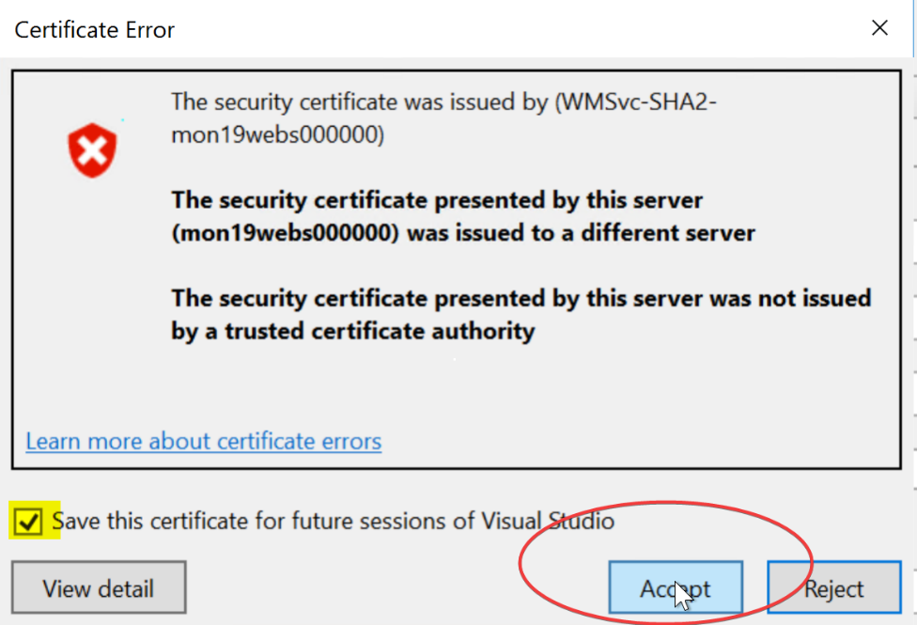

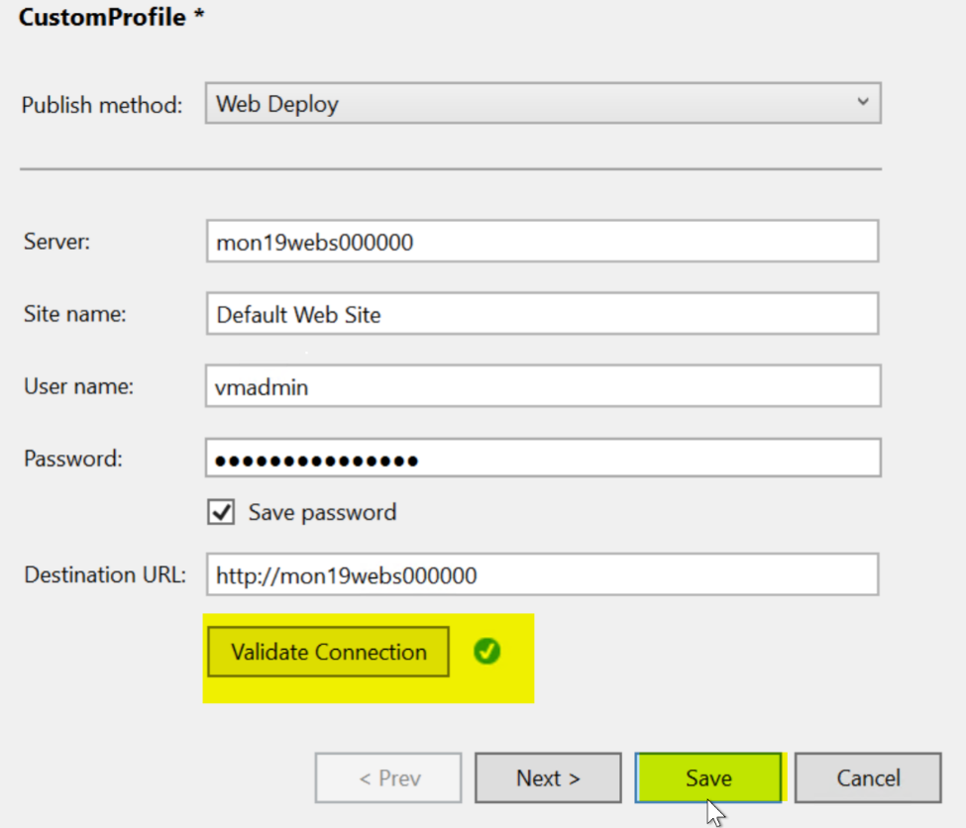

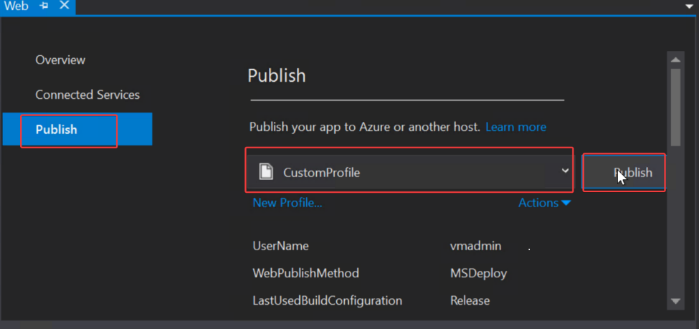

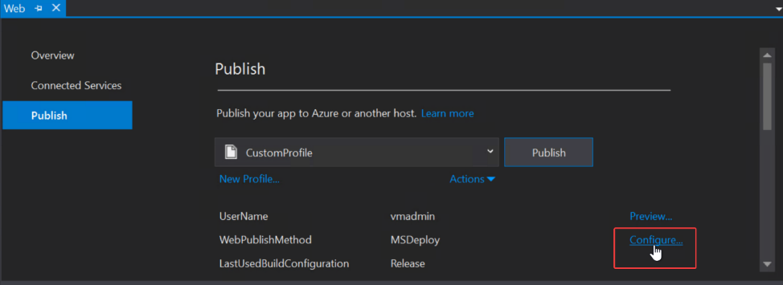

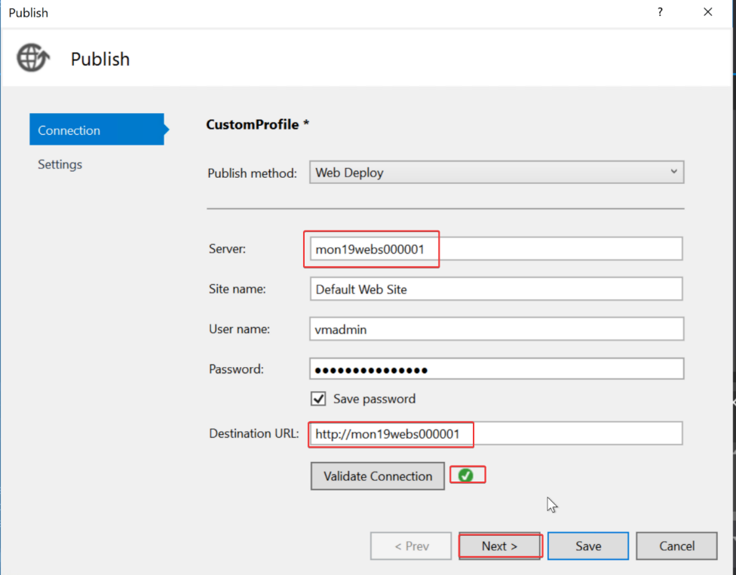

Click Next, Save then Publish to update the other instance in the Scale Set.

* Create a URL Ping test targeting the eShopOnWeb URL to Monitor Availability

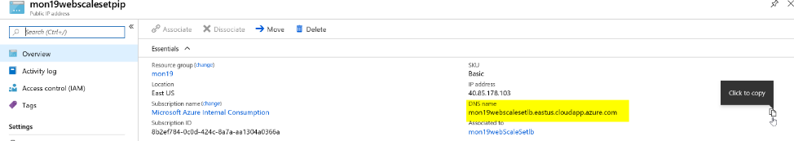

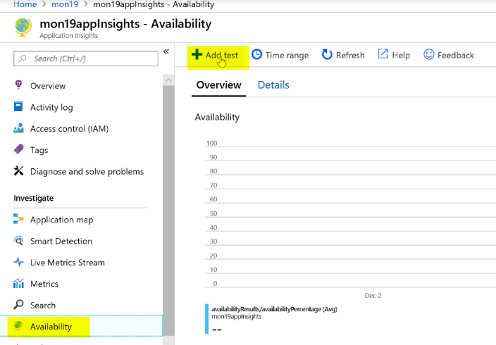

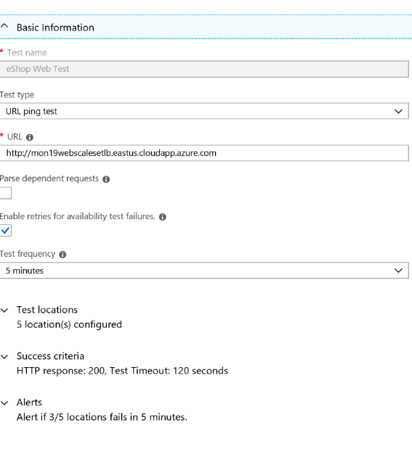

Create the test.

* + Generate some load and check out the results

From your laptop or the Visual Studio Server copy the code in the LoadScripts folder and modify it to your URL

for ($i = 0 ; $i -lt 100; $i++)

{

Invoke-WebRequest -uri http:// mon19webscalesetlb.eastus.cloudapp.azure.com/

}

Run the code to generate some load on your eShop site

* Create an autoscale rule on your scaleset based on the request count metric over 75 requests in less then 5 mins

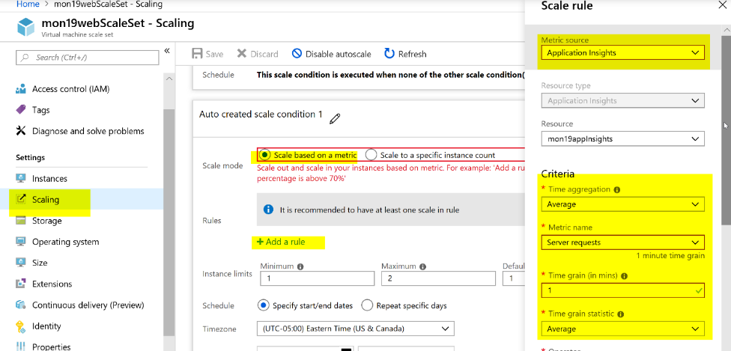

Scale Out Rule

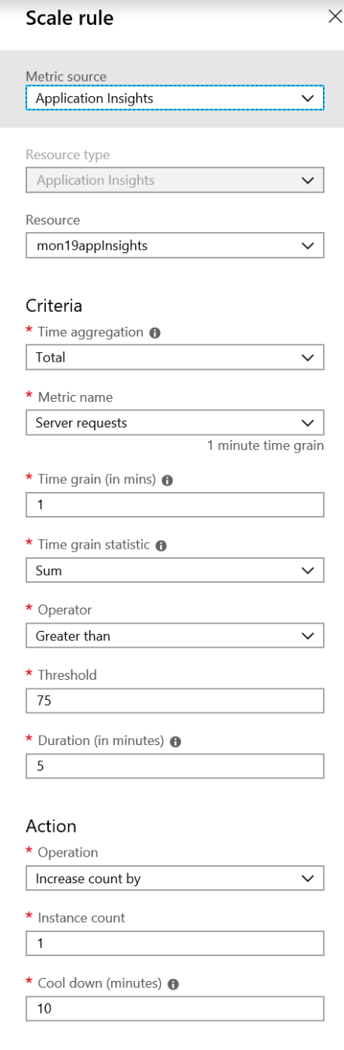

Click Add

Scale in Rule

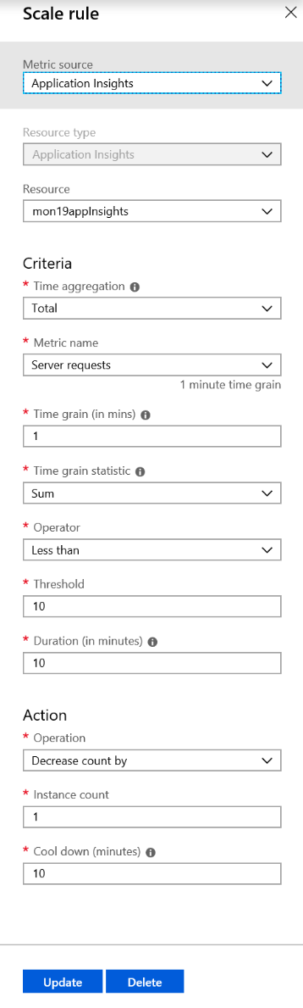

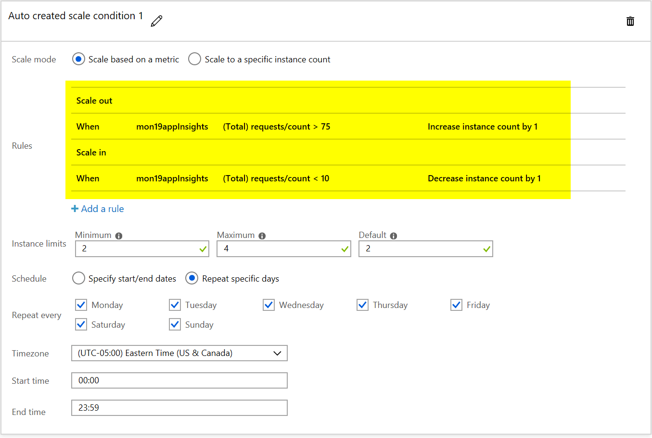

Click Save

Run the URL load script and after 5 mins you should see your scale set scale out using the Application Insights metrics.  
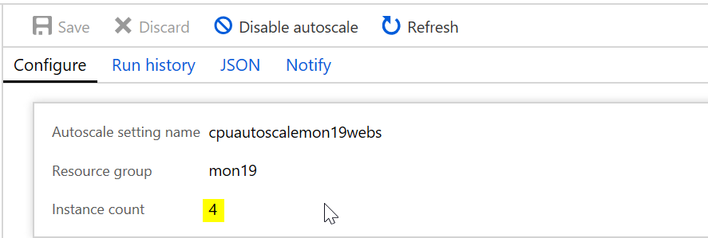  
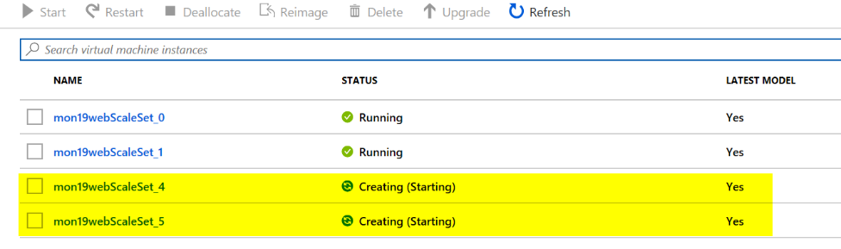

* Trip the exception that has been added and setup an alert for it.

To trip the exception,

1. Open your eShop site in your browser and login to the site  
   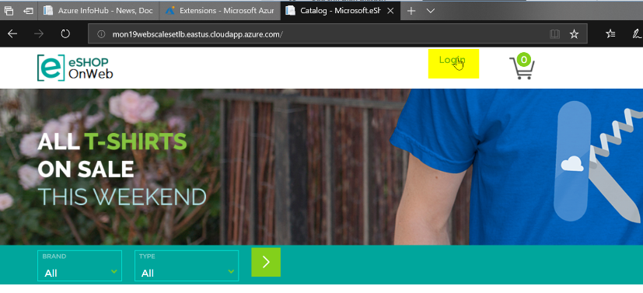  
   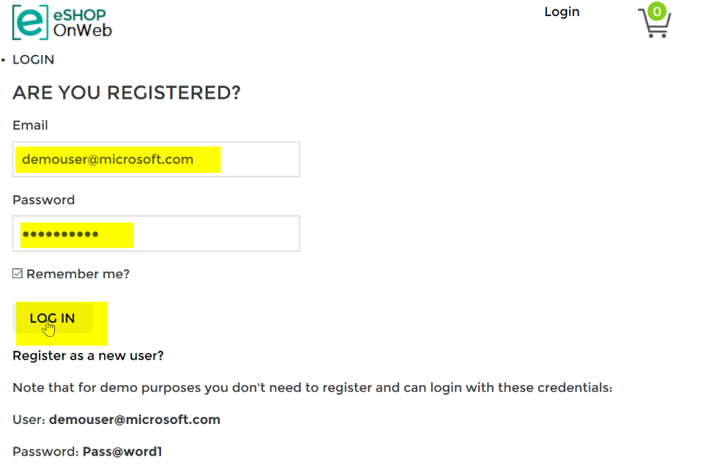
2. Try to change your password  
     
   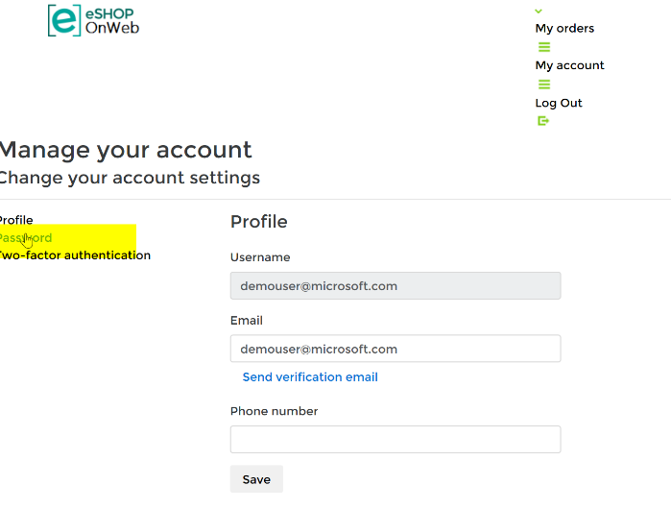

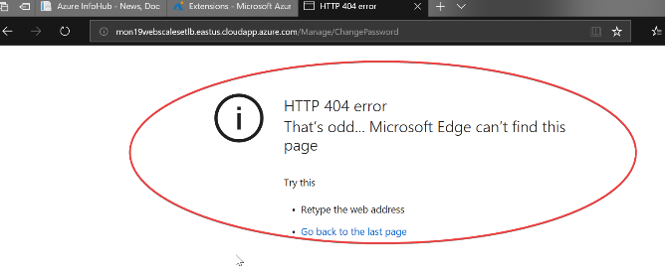

* + Find the exception in App Insights

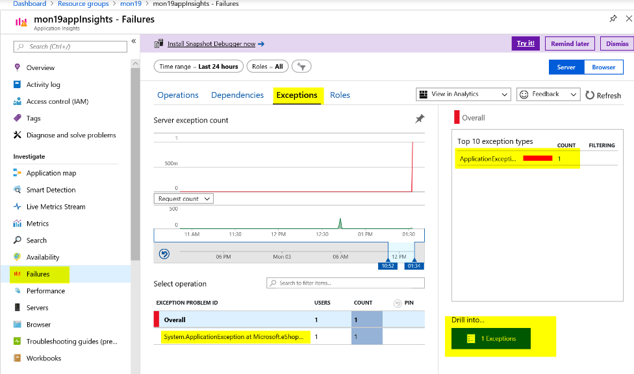

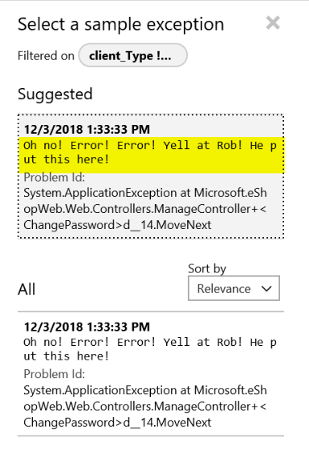

* Create Alerts based on Availability and exceptions

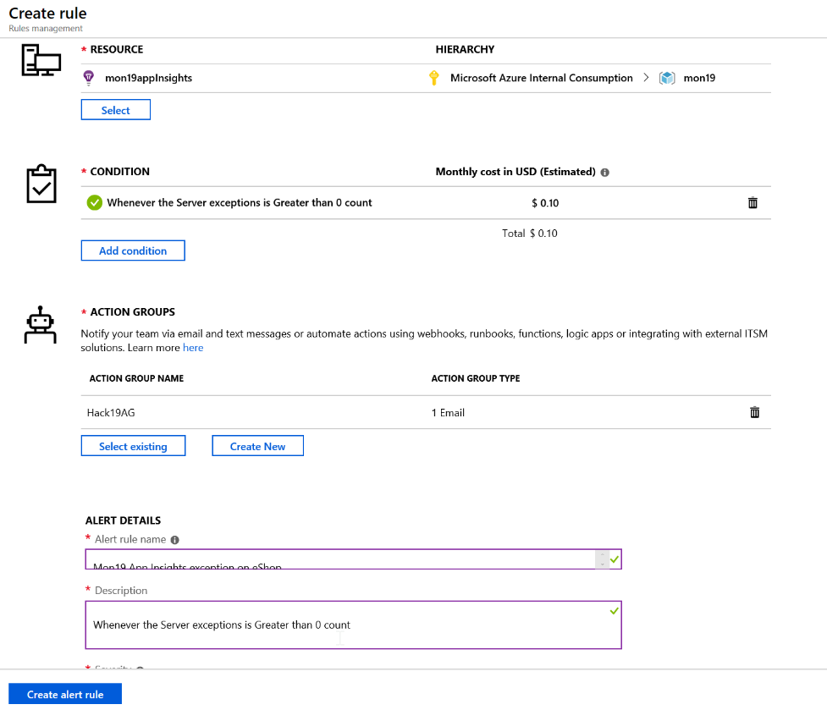

* First Team to email me an alert of the exception and a screenshot with your scaleset scale out based on the App Insights metric wins the challenge. Good luck